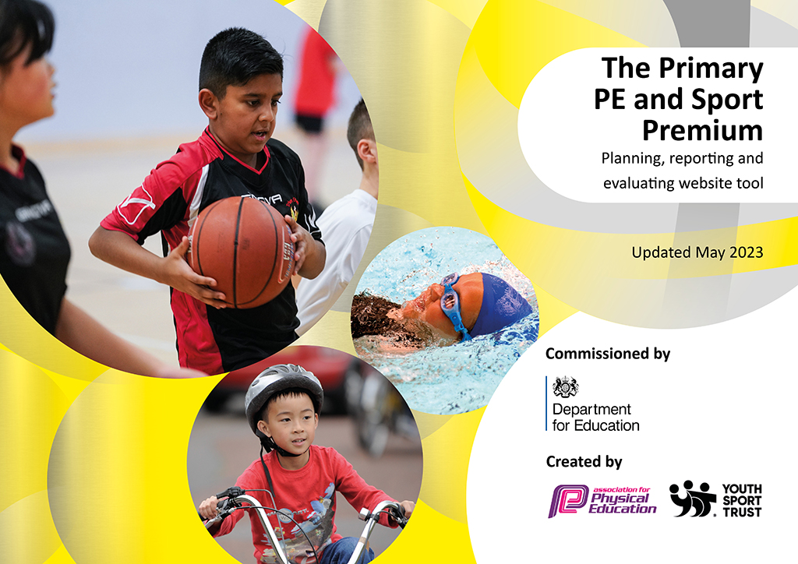
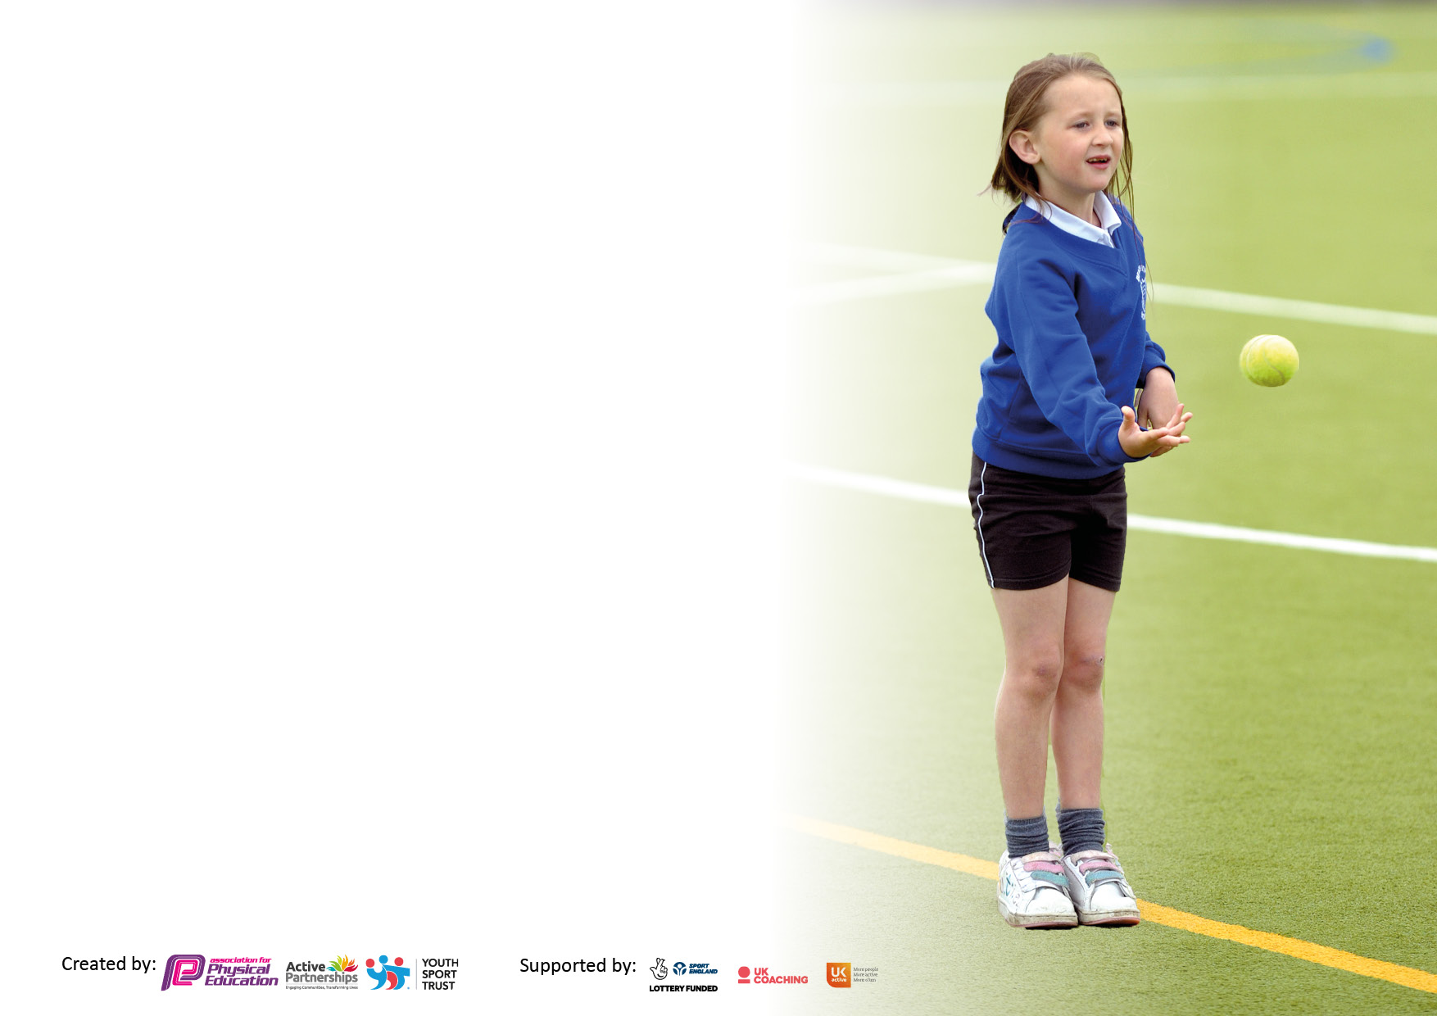

It is important that your grant is used effectively and based on school need. The Education Inspection Framework makes clear there will be a focus on ‘whether leaders and those responsible for governors all understand their respective roles and perform these in a way that enhances the effectiveness of the school’.

Under the Quality of Education judgement, Ofsted inspectors consider:
Intent - Curriculum design, coverage and appropriateness
Implementation - Curriculum delivery, teaching (pedagogy) and assessment
Impact - Attainment and progress

To assist schools with common transferable language, this template has been developed to utilise the same three headings which should make your plans easily transferable between working documents.

Schools must use the funding to make additional and sustainable improvements to the quality of Physical Education, School Sport and Physical Activity (PESSPA) they offer. This means that you should use the Primary PE and sport premium to:

- Develop or add to the PESSPA activities that your school already offers
- Build capacity and capability within the school to ensure that improvements made now will benefit pupils joining the school in future years
- The Primary PE and sport premium should not be used to fund capital spend projects; the school’s budget should fund these.

Please visit https://www.gov.uk/guidance/pe-and-sport-premium-for-primary-schools for the revised DfE guidance, including the 5 key indicators across which schools should demonstrate an improvement. This document will help you to review your provision and to report your spend. DfE encourages schools to use this template as an effective way of meeting the reporting requirements of the Primary PE and Sport Premium.

We recommend you start by reflecting on the impact of current provision and reviewing the previous spend.

Schools are required to publish details of how they spend this funding, including any underspend from 2021/2022, as well as on the impact it has on pupils’ PE and sport participation and attainment.

We recommend regularly updating the table and publishing it on your website throughout the year. This evidences your ongoing self-evaluation of how you are using the funding to secure maximum, sustainable impact. Final copy must be posted on your website by the end of the academic year and no later than the 31 July 2023.

Details with regard to funding
Please complete the table below.

Total amount carried over from 2021/22 | £0
Total amount allocated for 2022/23 | £19,580
How much (if any) do you intend to carry over from this total fund into 2023/24? | £0
Total amount allocated for 2022/23 | £19,580
Total amount of funding for 2022/23 to be reported on by 31st July 2023 | £19,580
Swimming Data
Please report on your Swimming Data below.

Meeting national curriculum requirements for swimming and water safety.

N.B. Complete this section as best you can. For example, you might have practiced safe self-rescue techniques on dry land which you can then transfer to the pool when school swimming restarts.
Due to exceptional circumstances priority should be given to ensuring that pupils can perform safe self-rescue even if they do not fully meet the first two requirements of the NC programme of study
What percentage of your current Year 6 cohort swim competently, confidently and proficiently over a distance of at least 25 metres?  N.B. Even though your pupils may swim in another year, please report on their attainment on leaving primary school at the end of the summer term 2023.  Please see note above | 65%
What percentage of your current Year 6 cohort use a range of strokes effectively [for example, front crawl, backstroke and breaststroke]?  Please see note above | 60%
What percentage of your current Year 6 cohort perform safe self-rescue in different water-based situations? | 35%
Schools can choose to use the Primary PE and sport premium to provide additional provision for swimming, but this must be for activity over and above the national curriculum requirements. Have you used it in this way? | No - Next year if more swimming lessons are possible we would like to ensure that more children in Year 6 are able to perform safe self-rescue.

Action Plan and Budget Tracking
Capture your intended annual spend against the 5 key indicators. Clarify the success criteria and evidence of impact that you intend to measure to evaluate for pupils today and for the future.

Academic Year: 2022/23 | Total fund allocated: | Date Updated: 13/07/2023
Key indicator 1: Increase confidence, knowledge and skills of all staff in teaching PE and sport |  |  |  | Percentage of total allocation:
 |  |  |  | %
Intent | Implementation |  | Impact
Your school focus should be clear on what you want the pupils to know and be able to do. What do they need to learn and to consolidate through practice: | Make sure your actions to achieve are linked to your intentions: | Funding allocated: | Evidence of impact:  What do pupils now know and what can they now do? What has changed? | Sustainability and suggested next steps:
- Sports coach attends regular training sessions to develop their skills in different subjects.  - Extra P.E lessons for pupils every half term so that the P.E lead/coach can teach new skills to other members of staff to build on their confidence.  - Upskill wider areas of the workforce to future proof and foster learning. | - PE Lead/Coach to attend online training ‘The impact of the Ofsted Research Review on your PE curriculum’ delivered by Real PE.  - PE Lead/Coach to attend  ‘The Ofsted Ready Department: Preparing for a Deep Dive’ masterclass delivered by Education Conferences  - Lunchtime staff trained and upskilled to deliver activities and new games during lunchtimes.  - Designated staff training days allocated for PE development.  - Online and digital platforms such as Seesaw to support learning, development and experience. | £120  £75  £285  £150 | - This course gave lots of ideas for how to ensure that all pupils can be included in P.E lessons. It looked at different teaching strategies and examples of both practical activities that can be used in school to have a clearer understanding of the pupils needs.  - Attending CPD was a good chance to share good practise with other schools and share these ideas with other members of staff back at school.  Using videos to evidence learning and also to help children see and analyse their own techniques and performances.
Key indicator 2: The engagement of all pupils in regular physical activity – Chief Medical Officers’ guidelines recommend that  primary school pupils undertake at least 30 minutes of physical activity a day in school |  |  |  | Percentage of total allocation:
 |  |  |  | %
Intent | Implementation |  | Impact
Your school focus should be clear on what you want the pupils to know and be able to do. What do they need to learn and to consolidate through practice: | Make sure your actions to achieve are linked to your intentions: | Funding allocated: | Evidence of impact:  What do pupils now know and what can they now do? What has changed? | Sustainability and suggested next steps:
- Children will take part in physical activities across all areas of the curriculum where appropriate. This will help the children to reach their 30 minutes of exercise.  - All children to receive 2 hours of P.E per week plus extra P.E lessons every few weeks.  - Children are offered up to 10 sporting clubs per week across mornings and afternoons. | - The lunchtime Supervisor and their lunchtime team will organise and deliver games and activities. This will be done in the BBA and rotated daily through each class. Also other activities will be delivered on the playground and surrounding areas too. All of these will be related where possible to curriculum and needs.  - Utilise timetabling opportunities to create opportunity for extra PE lessons delivered by upskilled available staff.  - Run morning and after school sports clubs changing activities/sports each half term to ensure a wide variety of activities for children, and that can support the curriculum.  - New equipment for children to play with at break and lunchtimes. This will include individual items as well as group activities.  - This equipment has also meant that we can offer a wider variety of clubs for the children.  - Using qualified swimming instructors to teach groups in the swimming lessons.  - Pool Hire  - Coach travel to swimming  lessons | £8,400  £1,350  £9,025  £ 2,875 | - By continuing to do this it has encouraged more children to be active at lunchtimes with activities changing daily.  - Learning is reinforced as children skills in PE are challenged more.  - Due to new equipment being purchased sports are now more accessible to all children.  - New equipment is also accessible to SEN children to help build on strength, memory or emotional techniques.  - Children are excited to use the equipment and will vary which machine they use. The equipment is always supervised by an adult.  - Year 5 were given the chance to have swimming lessons 1 x per week with qualified instructors. The lessons were differentiated based on abilities. | - Continue to use a lunchtime supervisor to run activities at lunchtimes. This will also apply to morning/after school clubs.  - Continue to develop staff internally to deliver PE at times where availability allows.  Purchase more equipment that can help SEN children in school.

Key indicator 3: The profile of PE and sport is raised across the school as a tool for whole school improvement |  |  |  | Percentage of total allocation:
 |  |  |  | %
Intent | Implementation |  | Impact
Your school focus should be clear on what you want the pupils to know and be able to do. What do they need to learn and to consolidate through practice: | Make sure your actions to achieve are linked to your intentions: | Funding allocated: | Evidence of impact:  What do pupils now know and what can they now do? What has  changed? | Sustainability and suggested next steps:
- We have a qualified sports coach who ensures that high quality teaching of P.E in seen across the school. These coaches will often take pupils to events outside of school to compete as well as experienced teachers who have a link to.  - Children’s achievements are recognised in whole school assembly and on the school twitter page. They can also bring in any awards that they have achieved out of school to share with the class.  P.E has a positive impact within our school, as some children relate strongly to it, which can assist during classroom requirements. We use P.E activities within our lessons where possible. | - Children have at least 2 hours of P.E each week (this can include swimming) with some extra P.E lessons for the children throughout the year.  - Use the School Games formats for children to become involved in an appropriate level of competition for each year group.  - Children are fully engaged in their P.E lessons and are learning new skills that they may not experience out of school. Experienced P.E coach will teach technique according to the ability of the children.  - Pupils take part in intra school competitions with the sports coach.  - Children are learning sports within school that they may not be able to access at home.  - Being involved in competitions with other schools in the local area. | £ | - The children see the sports coaches and teachers as role models within the school due to their own experiences in particular sports. This has a good impact on the children’s confidence and gives them someone to aspire to be like.  - Due to a wider range of clubs we are getting more children becoming involved in sporting activities both at lunchtime and after school. There are more children with SEN joining after school and morning clubs.  - Girls football has become more popular within the school due to us competing in more competitions and achievements shown in assembly. | - A permanent P.E coach so that lessons are consistent throughout the year and good respect is shown from the pupils.  - Introduce Year 6 sport leaders and a sporting committee. They can help out with sporting events happening in school.  - Host more sporting events within school and invite other schools to take part.  - Take part in more competitions with neighbouring schools.  - More teaching staff to host a sports club so that the pupils can see other skills that they have.  - A clear assessment is in place so that there is clear evidence of skill progression and development.
Key indicator 4: Broader experience of a range of sports and physical activities offered to all pupils |  |  |  | Percentage of total allocation:
Intent | Implementation |  | Impact
Your school focus should be clear on what you want the pupils to know and be able to do. What do they need to learn and to consolidate through practice: | Make sure your actions to achieve are linked to your intentions: | Funding allocated: | Evidence of impact:  What do pupils now know and what can they now do? What has  changed? | Sustainability and suggested next steps:
- At New Invention we want to ensure that there are a variety of sports/activities that will suit all children. We like to offer children activities that they may not be able to access at home.  - We offer these activities in:  - Morning clubs (5 per week)  - P.E lessons (At least 2 per week per class)  - Swimming lessons (Year 4 and 5-1 term per year)  - Lunchtime Club (5 per week)  - Afterschool Clubs (5 per week)  - Holiday Clubs (5 days per week)  - Extra P.E lessons (1 class per week)  - Competitions (throughout the year) | - Our school continues to offer a range of sports for the children to participate in including: invasion games, ball and net, gymnastics and dance and multi-sports. We offer these in our P.E lessons, morning clubs, lunchtime clubs and after school clubs.  - We try to range which children are involved in the clubs to give everyone a fair chance of taking part. |  | - We have ensured that more children are taking part in sporting activities from the following groups:  -Pupil Premium  -SEND  -Boys/Girls  To ensure that everyone has an equal opportunity. | - Invite out of school companies in for special sporting weeks.  - More sporting competitions within school-linked to the house points. This could end with a sporting team of the year  - Try to host clubs for less known sports to teach the pupils new skills.  - Buy more equipment

Key indicator 5: Increased participation in competitive sport |  |  |  | Percentage of total allocation:
 |  |  |  | %
Intent | Implementation |  | Impact
Your school focus should be clear on what you want the pupils to know and be able to do. What do they need to learn and to consolidate through practice: | Make sure your actions to achieve are linked to your intentions: | Funding allocated: | Evidence of impact:  What do pupils now know and what can they now do? What has  changed? | Sustainability and suggested next steps:
- As a school we want to ensure that every pupil has the opportunity to represent the school in a competition.  - Give pupils who are not able to do sports outside of school the chance to take part in competitions between other schools.  We offer a variety of sports in our morning and after school clubs to reach a wider range of children. | - Building on getting children who are less active/ confident to become involved in competitions both within and out of school.  - Ensure children in school all have the correct P.E kit to create a sense of pride when representing the school.  - Have a team kit for children representing the school so that they have a sense of pride.  New equipment has been purchased so that the school can provide a wider range of clubs and children can learn new skills. |  | - Children are building their confidence and knowledge on how to compete.  - Children are aware of the school values that they have to show when representing the school.  - Archery, Boules, Croquet set and Axe throwing equipment purchased for a wider range of activities.  - We have also bought different styles of balls so that we can differentiate activities with all abilities throughout the school. | - Hold a competition within our school. This could be football or Basketball in the BBA  - Continue mini competitions within school as well as sports day within the different houses.  - More links with schools in the area to host/ be part of competitive sports.

Signed off by
Head Teacher: | A Pearson
Date: | 25th July 2023
Subject Leader: | A Martin
Date: | 25th July 2023
Governor:
Date:

