New Invention Junior School
Mental to Written Policy


SUBTRACTION
_
Practical – pictorial – abstract
In order for pupils to develop a concrete understanding of calculation, they should progress through the three stages of formal calculations (practical, pictorial, abstract).

Practical
Addition & subtraction
Pupils should initially be using the following apparatus / equipment to support their understanding of what addition & subtraction means (once place value has been established).

Base ten / Deins
These should be used along with place value mats, initially.

Without bridging 10
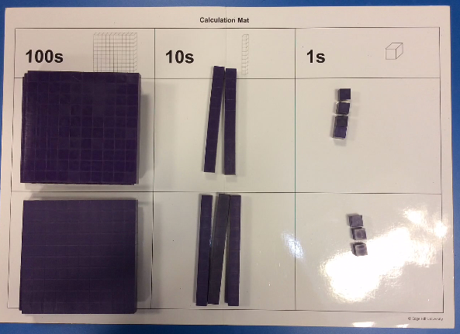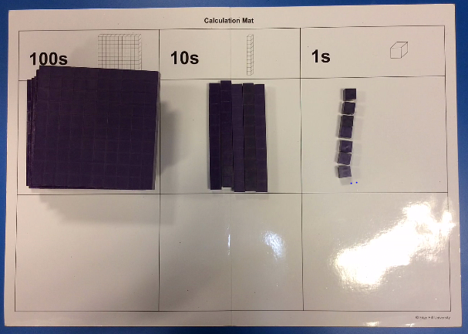
324 + 233 = 557

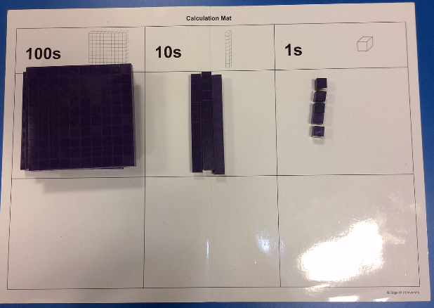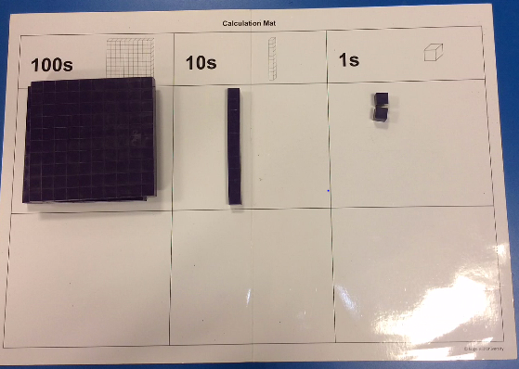
335 – 123 = 212
Bridging 10 / 100
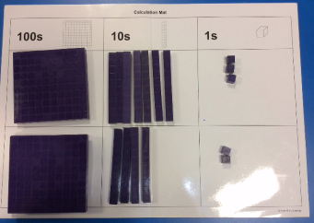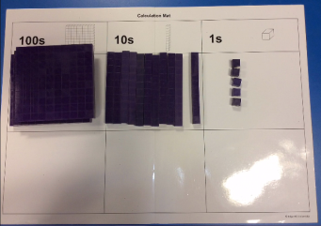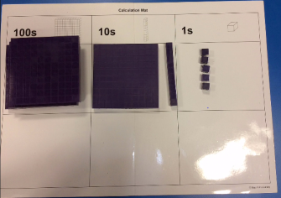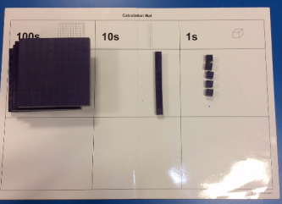
273 + 242 = 515
Pupils should combine and then exchange the tens rods for hundreds blocks, when bridging 10/100’s.
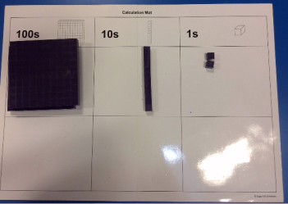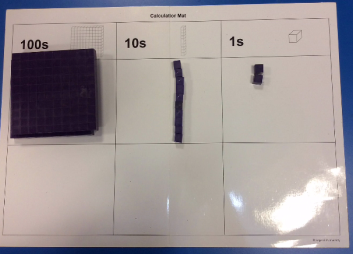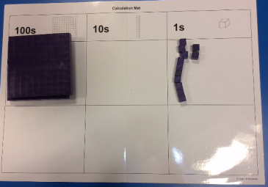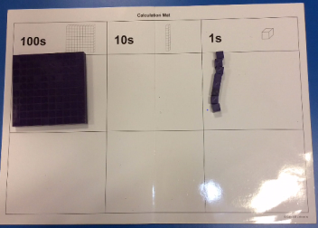
212 – 104 = 108
When subtracting with the need to exchange, pupils should exchange the 100 / 10s rods first before subtracting the required amount.

Numicon
Numicon is ideal for number bonds, especially to 1, 10 and 100. And bonds within 10, 20 and 100. Each shape could represent the whole number corresponding to the holes, or it could represent 10 0r 100 times larger or smaller.
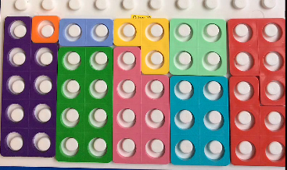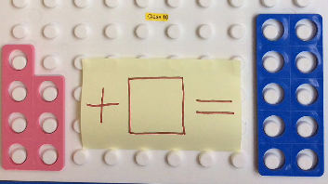
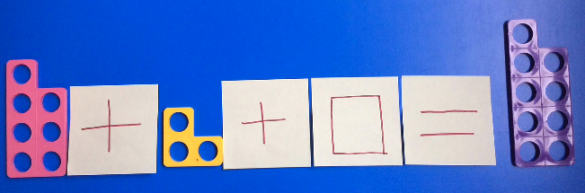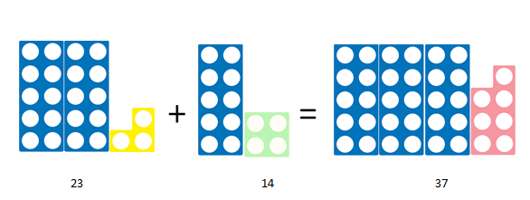

Number rods
Number rods (found in Numicon resources) can be used for demonstrating the bar model, where pupils can see how two numbers are combined to make a larger answer; the rods can therefore represent any value.
These images could represent finding pairs of numbers to equal a larger value, or finding the missing value needed to be added to a smaller number or subtracted from a larger number.

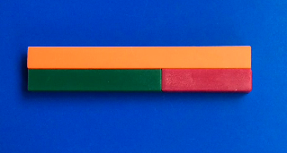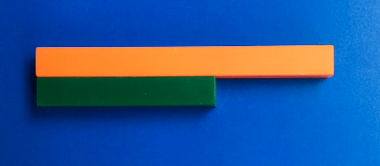
Multiplication & division
Pupils should initially be using the following apparatus / equipment to support their understanding of what multiplication means (once place value has been established).

Base ten / Deins
Numicon
This an ideal resource to represent arrays as a model of multiplication or division.
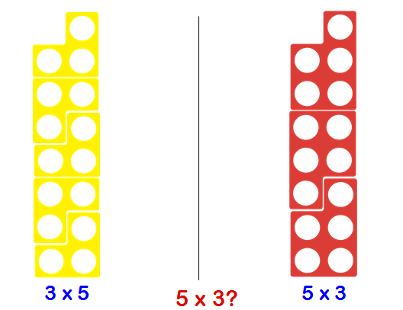
Division can also be shown in both ways, using Numicon: as sharing or grouping.

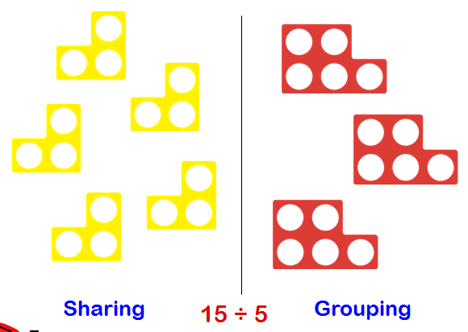

Number rods
Number rods or bar model, can be used for division or scaling, to identify how many of one value fit in to the larger value.
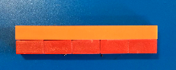

These rods represent 2 x 5 being equal to 10, or 10 split equally in to 5 is 2.

Pictorial
Once pupils are secure with practical apparatus and can explain concepts using it, they should then be moving on to representing calculations pictorially, as shown below.
Addition & subtraction
Bar Model
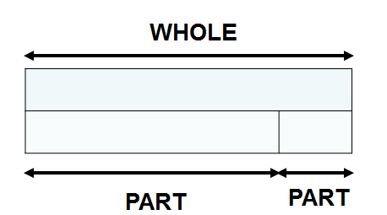

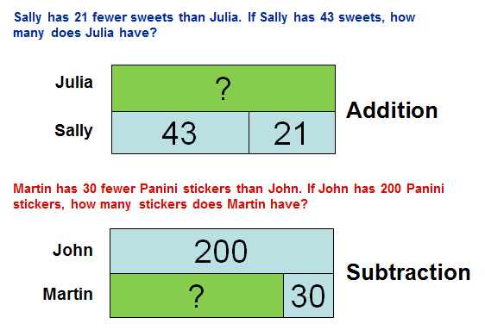

Multiplication & Division
Bar Model
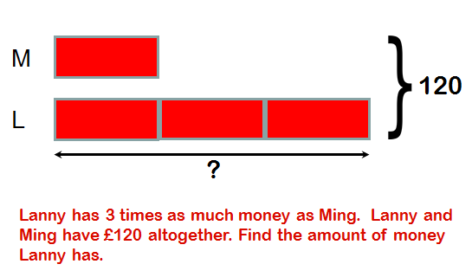
Abstract
Mental Calculations
Most mental calculations can be solved using the strategies of Rapa Coda Numbo. This is an acronym for five different strategies. (please refer to our visual calculation policy – TBA)
RA – Round & Adjust
PA – Partitioning
CO – count on/back
DA – double & adjust
Numbo – Number Bonds

RA
Round and adjust can be used when a number is close to a multiple of 10, 100 or 1000, in order to make it quicker to add, subtract or multiply. The answer will then have to be adjusted to compensate for rounding.
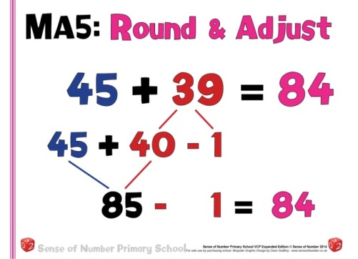

PA
Partitioning a number means to split it in to its place value, and calculate each digit separately before recombining. This can be used for addition, subtraction and multiplication.
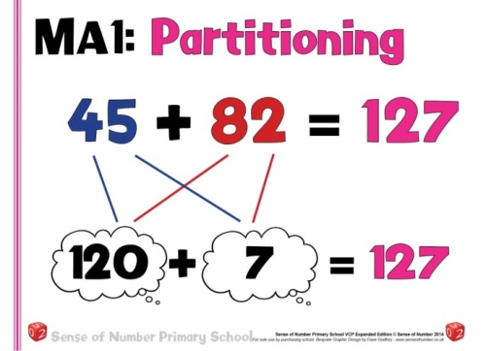

CO
Count on or back can be used for both addition and subtraction. It is simply starting at one of the numbers and counting in 1’s, 2’s 10 etc. till the final number is reached.
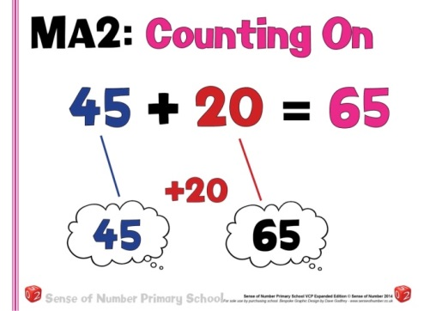

DA
Double and adjust is ideally suited to addition, subtraction and multiplication. When a pair of numbers are close to being equal, the calculation can be carried out as if they were the same and then the answer adjusted accordingly.
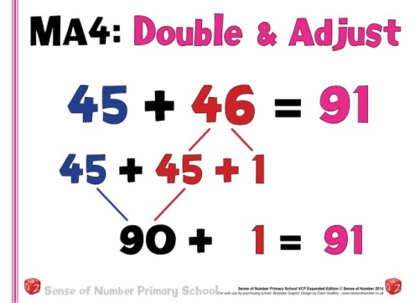

Numbo
Number bonds are essential for quick mental calculation, with known number bonds to and within 10, these can then be used to derive a range of addition and subtraction calculations.
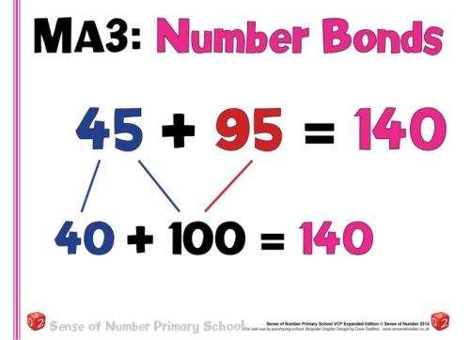

Mental subtraction of Numbers
To subtract successfully, children need to be able to:
Year 3 | Year 4 | Year 5 | Year 6
Subtract pairs of 2 digit numbers without bridging 10  Find 10 or 100 more/less than a given number  Subtract by counting on when numbers are close in value  Subtract 2 digit numbers, to 20, by counting back in 10s and 1s  Subtract any 2 digit numbers by counting back in 10s and 1s | Find 1000 more/less than a given number  Find 1100 / 110 more/less than any given number  Find change from £10, £20 and £50 by counting on (Rapa Coda Numbo)  Add and subtract £1, 10p and 1p to amounts of money (Rapa Coda Numbo)  Subtract any two 2 digit numbers by partitioning or counting on (Rapa Coda Numbo) | Find 1100 / 110 / 11 more or less than any given number  Add and subtract decimal numbers which are near multiples of 1 or 10, including money (£6.34-1.99 or £34.59-£19.95) (Rapa Coda Numbo) | Use number bonds to 1 to perform mental subtraction of any pair of 1-decimal-place numbers  Use number bonds to 10 to perform mental subtraction of any pair of 1-decimal-place numbers

Written subtraction of Numbers

Stage 1: Numberline – Counting back
- By Year 2/3  - The empty number line helps to record or explain the steps in mental subtraction. A calculation like 74 – 27 can be recorded by counting back 27 from 74 to reach 47. The empty number line is also a useful way of modelling processes such as bridging through a multiple of ten.  - With practice, children will need to record less information and decide whether to count back or forward. It is useful to ask children whether counting up or back is the more efficient for calculations such as 57 – 12, 86 – 77 or 43 – 28.  - Subtraction can be recorded using partitioning to write equivalent calculations that can be carried out mentally. For  74 – 27 this involves partitioning the 27 into 20 and 7, and then subtracting from 74 the 20 and the 7 in turn. Some children may need to partition the 74 into 70 + 4 or 60 + 14 to help them carry out the subtraction. | Steps in subtraction can be recorded on a number line. The steps often bridge through a multiple of 10.  15 – 7 = 8  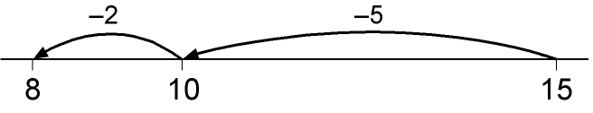  74 – 27 = 47 worked by counting back:  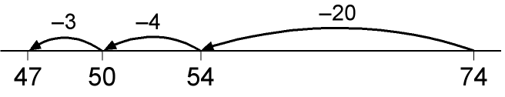  The steps may be recorded in a different order:  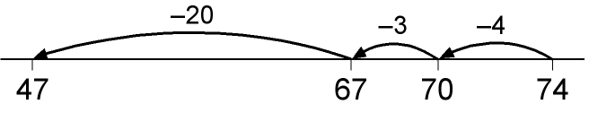  or combined:  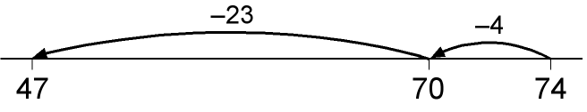  This requires children to subtract a single-digit number or a multiple of 10 from a two-digit number mentally. The method of recording links to counting back on the number line.
Stage 1: Numberline – counting on
- By Year 2/3  - The steps can also be recorded by counting up from the smaller to the larger number to find the difference, for example by counting up from 27 to 74 in steps totalling 47.  - The mental method of counting up from the smaller to the larger number can be recorded using either number lines or vertically in columns. The number of rows (or steps) can be reduced by combining steps. With two-digit numbers, this requires children to be able to work out the answer to a calculation such as 30 + = 74 mentally.  - “to make” may be replaced by an arrow as children gain understanding and begin to find writing to make unnecessarily slow. | 74 – 27 = 47  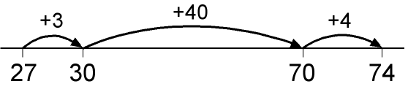  3 + 40 + 4 = 47  or: 74 -27 = 47  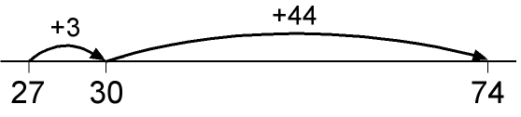 74  3 + 44 = 47
- With three-digit numbers the number of steps can again be reduced, provided that children are able to work out answers to calculations such as 178 + = 200 and 200 + = 326 mentally.  - The most compact form of recording remains reasonably efficient. | 326 – 178 = 148  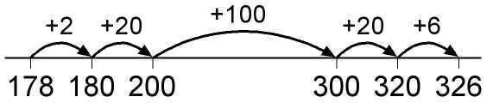  or:  326 – 178 = 148  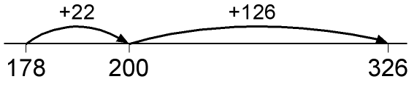
- The method can be used with decimals where no more than three columns are required. However, it becomes less efficient when more than three columns are needed.  - This counting-up method can be a useful alternative for children whose progress is slow, whose mental and written calculation skills are weak and whose projected attainment at the end of Key Stage 2 is towards the lower end of level 4. | 22.4 – 17.8 = 4.6  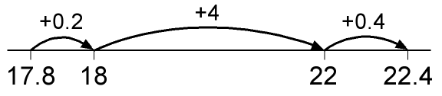  or:  22.4 – 17.8 = 14.6  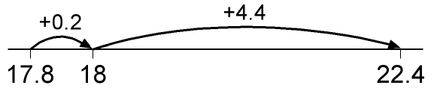
Stage 2: Expanded column method
- By Year 3  - Partitioning the numbers into tens and units and writing one under the other mirrors the column method, where units are placed under units and tens under tens.  - This does not link directly to mental methods of counting back or up but parallels the partitioning method for addition. It also relies on secure mental skills.  - For three or more digit numbers, start by subtracting the units, then the tens, then the hundreds. Refer to subtracting the tens, for example, by saying ‘sixty take away forty’, not ‘six take away four’.  - When borrowing, begin by reading aloud the number from which we are subtracting: ‘five hundred and sixty-three’. Then discuss the hundreds, tens and units components of the number, and how 500 + 60 can be partitioned into 400 + 160. The subtraction of the tens becomes ‘160 minus 70’, an application of subtraction of multiples of ten.  - Children who need a concrete demonstration of this could use Dienes Apparatus. | Partitioned numbers are then written under one another:  Example: 74 − 27  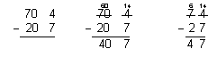  Example: 741 − 367  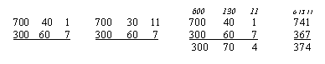  Example: 563 − 241, no adjustment or decomposition needed  Expanded method  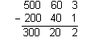  Example: 563 − 271, adjustment from the hundreds to the tens, or partitioning the hundreds  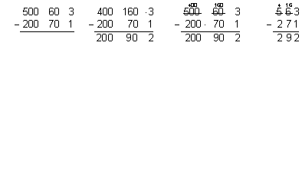
Stage 3: Compact column method
- By Year 4  - The expanded method leads children to the more compact method so that they understand its structure and efficiency. The amount of time that should be spent teaching and practising the expanded method will depend on how secure the children are in their recall of number facts and with partitioning.  - By the end of Year 4 pupils should calculate with up to 4 digits.  - To extend further, pupils should work with this same method, including decimals, in the context of money. | Numbers are no longer partitioned, now an understanding of borrowing using place value.  Example: 74 − 27  Example: 741 − 367  