

Relationships and Sex Education Policy

INTRODUCTION
This policy sets out our school’s approach to statutory Relationships Education and non-statutory Sex Education. It was produced by the RSE co-ordinator based upon guidance given by Walsall Council, alongside the Head teacher, Senior Leadership Team, Designated Safeguarding Lead and the Chair of Governors alongside input from parents and carers from the school community. We have based our school's relationships and sex education policy on the statutory guidance document “Relationships and Sex Education (RSE) and Health Education” (DfE, 2019) and the PSHE Association’s supplementary guidance “Writing your school’s relationships and sex education (RSE) policy” (PSHE Association, September 2018).
Department for Education guidance states that the teaching of Sex Education in primary schools remains non-statutory, with the exception of the elements of sex education contained in the Science National Curriculum including the main external body parts, the human life cycle (including puberty) and reproduction in some plants and animals. Other related topics fall within the statutory requirements for Health Education, such as puberty and menstrual wellbeing. Within the statutory guidance document for RSE and Health Education, the DfE also encourages schools to deliver age-appropriate sex education if they feel their pupils need this information:
“It will be for primary schools to determine whether they need to cover any additional content on sex education to meet the needs of their pupils. Many primary schools already choose to teach some aspects of sex education and will continue to do so, although it is not a requirement…it is important that the transition phase before moving to secondary school supports pupils’ ongoing emotional and physical development effectively. The Department continues to recommend therefore that all primary schools should have a sex education programme tailored to the age and the physical and emotional maturity of the pupils. It should ensure that both boys and girls are prepared for the changes that adolescence brings and – drawing on knowledge of the human life cycle set out in the national curriculum for science - how a baby is conceived and born”
Within this policy, as in the DfE guidance, Relationships Education is defined as teaching about the fundamental building blocks and characteristics of positive relationships, with particular reference to friendships, family relationships, and relationships with other children and with adults. Our definition of Relationships Education includes all of those elements defined within this statutory topic – these are detailed below in the ‘RSE Curriculum’ section.
Sex Education is defined as teaching children how human reproduction occurs, including how a baby is conceived. This draws on knowledge of the human life cycle set out in the national curriculum for science. For the purposes of this policy, we specifically identify any non-statutory Sex Education that falls outside of Science and those related elements (the physical changes associated with puberty) within statutory Health Education.
RATIONALE AND ETHOS
RSE is underpinned by the ethos and values of our school as reflected in our whole school motto, “Respect for All”. Our vision is to create a safe, positive and stimulating environment in which all members of the school community learn and grow in confidence, knowledge and skills.
Through our PSHE programme we aim to provide children with the knowledge, skills and understanding they need to lead confident, healthy, independent lives and to become informed, active and responsible citizens. In providing children with an understanding of healthy and respectful relationships and appropriate boundaries, we consider effective RSE to be a fundamental part of our approach to supporting pupils to grow into confident, caring, responsible and respectful young citizens.
RSE is lifelong learning about personal, physical, moral and emotional development. It is set in the context of clear values about the understanding of the importance of stable and loving relationships, respect, love and care, for family life. It should teach children and young people to develop and form positive values, attitudes, personal and social skills, and increase their knowledge and understanding of how to make informed decisions and life choices.
We see our RSE programme as supportive of our work as a Rights Respecting School, with particular reference to Articles 19 and 34 (the right to be protected from abuse) and Article 17 (the right to reliable information from a variety of sources).
ROLES AND RESPONSIBILITIES
Relationships and Sex Education (RSE) forms part of the Personal, Social, Health and Economic (PSHE) education curriculum in our school. The RSE programme is led by the RSE Co-ordinator with the support of the Senior Leadership Team.
RSE lessons are taught by class teachers as both cross-curricular and standalone lessons, supported by expert visitors as appropriate and necessary. Teaching staff receive training in the delivery of the RSE curriculum through dedicated staff meetings, led by the RSE Co-ordinator with the support of external experts as required.
As a school, we are aware that the primary responsibility for providing children’s RSE lies with parents and carers. We recognise the need to work with parents and carers to ensure a shared understanding of RSE and to deliver an effective programme that meets the needs of our pupils.

THE RSE CURRICULUM
Effective Relationships & Sex Education can make a significant contribution to the development of the personal skills needed by pupils if they are to establish and maintain positive, healthy relationships. It also enables young people to make responsible and informed decisions about their health and well-being.
As is required by the new statutory guidance, parents have also been consulted on the relevant content within the policy. 142 of our parents and carers responded to a questionnaire about our RSE Policy From that questionnaire, over 94% of all responses believed that children should be taught the different characteristics of a healthy family life and that others' families sometimes look different from their own, over 97% of responses agreed that children should be able to recognise what is and know how to report emotional, physical and sexual abuse at an age-appropriate level and 13% of responses believed that their child/children is not aware of the characteristics of a healthy relationship.
We believe that involving parents and carers ensures that the curriculum we provide for our pupils is reflective of the requirements placed upon us and also of the needs of our school community.
STATUTORY RELATIONSHIPS EDUCATION CONTENT
As part of our PSHE/Relationships Education programme of study, children will be taught what a relationship is; the different types of relationships they might have e.g. with family members, friends, and other adults; the importance of healthy and secure relationships to wellbeing; what constitutes a healthy relationship, in person and online; how to set and observe appropriate boundaries in relationships; how to recognise when a situation is unsafe; strategies for dealing with situations that they find uncomfortable or that are unsafe; and sources of help and advice.
A summary of the key objectives of the statutory Relationships Education curriculum is set out below.
- Families and people who care for me
Children should know:
- that families are important for children growing up because they can give love, security and stability.
- the characteristics of healthy family life, commitment to each other, including in times of difficulty, protection and care for children and other family members, the importance of spending time together and sharing each other’s lives.
- that others’ families, either in school or in the wider world, sometimes look different from their family, but that they should respect those differences and know that other children’s families are also characterised by love and care.
- that stable, caring relationships, which may be of different types, are at the heart of happy families, and are important for children’s security as they grow up.
- that marriage represents a formal and legally recognised commitment of two people to each other which is intended to be lifelong.
- how to recognise if family relationships are making them feel unhappy or unsafe, and how to seek help or advice from others if needed.

- Caring friendships
Pupils should know:
- how important friendships are in making us feel happy and secure, and how people choose and make friends.
- the characteristics of friendships, including mutual respect, truthfulness, trustworthiness, loyalty, kindness, generosity, trust, sharing interests and experiences and support with problems and difficulties.
- that healthy friendships are positive and welcoming towards others, and do not make others feel lonely or excluded.
- that most friendships have ups and downs, and that these can often be worked through so that the friendship is repaired or even strengthened, and that resorting to violence is never right.
- how to recognise who to trust and who not to trust, how to judge when a friendship is making them feel unhappy or uncomfortable, managing conflict, how to manage these situations and how to seek help or advice from others, if needed.

- Respectful relationships
Pupils should know:
- the importance of respecting others, even when they are very different from them (for example, physically, in character, personality or backgrounds), or make different choices or have different preferences or beliefs.
- practical steps they can take in a range of different contexts to improve or support respectful relationships.
- the conventions of courtesy and manners.
- the importance of self-respect and how this links to their own happiness.
- that in school and in wider society they can expect to be treated with respect by others, and that in turn they should show due respect to others, including those in positions of authority.
- about different types of bullying (including cyberbullying), the impact of bullying, responsibilities of bystanders (primarily reporting bullying to an adult) and how to get help.
- what a stereotype is, and how stereotypes can be unfair, negative or destructive.
- the importance of permission-seeking and giving in relationships with friends, peers and adults.

- Online relationships
Pupils should know:
- that people sometimes behave differently online, including by pretending to be someone they are not.
- that the same principles apply to online relationships as to face-to-face relationships, including the importance of respect for others online including when we are anonymous.
- the rules and principles for keeping safe online, how to recognise risks, harmful content and contact, and how to report them.
- how to critically consider their online friendships and sources of information including awareness of the risks associated with people they have never met.
- how information and data is shared and used online.

- Being safe
Pupils should know:
- what sorts of boundaries are appropriate in friendships with peers and others (including in a digital context).
- about the concept of privacy and the implications of it for both children and adults; including that it is not always right to keep secrets if they relate to being safe.
- that each person’s body belongs to them, and the differences between appropriate and inappropriate or unsafe physical, and other, contact.
- how to respond safely and appropriately to adults they may encounter (in all contexts, including online) whom they do not know.
- how to recognise and report feelings of being unsafe or feeling bad about any adult.
- how to ask for advice or help for themselves or others, and to keep trying until they are heard.
- how to report concerns or abuse, and the vocabulary and confidence needed to do so.
- where to get advice e.g. family, school and/or other sources.

NON-STATUTORY SEX EDUCATION
As part of statutory Health Education, children are taught in an age appropriate way about puberty and the associated physical and emotional changes from Year 3 onwards. As part of the science curriculum, children learn in Year 5 about how reproduction occurs in some plants and animals.
We recognise that children in younger year groups may ask questions that cannot be answered without reference to content from older year groups. Should this occur, we will respond by telling them that they will learn about that when they are older. Please see the relevant section within this policy for further information on how teachers manage difficult questions in RSE.
As is legally prescribed, parents have a right to withdraw their children from any additional non-statutory sex education lessons, a curriculum which over 90% of respondents agreed our school should offer in a 2020 parent and carer questionnaire was sent out. Please see the relevant section within this policy in regard to the process of withdrawing consent.
DELIVERY
All elements of our Relationships & Sex Education programme will be delivered in an age-appropriate and sensitive manner as part of our regular programme. RSE is delivered predominantly by class teachers in mixed gender groups, other than when it is deemed more appropriate for topics to be covered in single sex groups; this will be decided by the class teacher after discussion with the subject lead.
Occasionally, appropriate and suitably experienced and/or knowledgeable visitors from outside school may be invited to contribute to the delivery of RSE in school, for example the school nurse. All visitors will be familiar with and understand the school’s RSE policy and be expected to work within it.
TEACHING AND LEARNING STRATEGIES
We aim to provide an environment and atmosphere for RSE where pupils feel safe, relaxed, unintimidated, and focused; and where they have confidence and trust in the knowledge, ability and skills of staff in school. This ensures that both pupils and staff feel fully confident in engaging in age-appropriate discussions around potentially sensitive topics and themes.
To provide clarity and create a safe learning environment, at the beginning of each session, a set of ground rules will be agreed by the class based on a school-wide template. As a minimum, ground rules are likely to include the following basic guidelines:
- Listen politely to each other;
- Everyone gets a turn - if they want one;
- Respect everybody's contribution;
- No personal information - no names;
- No personal questions;
- No making fun;
- An age-appropriate rule around confidentiality and safeguarding.
Children and teachers are free to suggest and agree further ground rules as appropriate to the topic of each lesson.
Other teaching and learning strategies utilised in RSE to establish a safe learning environment include the following techniques:
- Using 'distancing' techniques such as role play, case studies, videos etc. to depersonalise sensitive issues.

- Anonymous question boxes. These can help children to have the confidence to ask sensitive questions, and they provide an opportunity for teachers to pre-empt questions that might not be age appropriate or that might raise safeguarding or child protection concerns.It will be emphasised to children that any voluntary sharing of information should be anonymous (for example “someone I know…” rather than “I” or naming names).

- Should personal questions be asked of either children or staff, children will be reminded that the ground rules for RSE prohibit personal questions. Although staff may draw on their personal experiences to answer certain questions, for example around menstruation, this should always be depersonalised and discussed in third person rather than first person.
All staff teaching RSE will be supported and advised by the RSE lead and senior leadership team on these matters as required.
MANAGING DIFFICULT QUESTIONS
During both formal and informal PSHE/RSE sessions, pupils are encouraged to ask questions. Any questions from pupils are answered according to the age and maturity of the pupil concerned, and if the teacher delivering the session deems it appropriate to answer. Teachers will:
- use specific ground rules for this work which will clarify boundaries for children/young people, and mitigate disclosures in class
- clarify that personal questions should not be asked
- clarify that pupils should not give out personal information in class but speak to someone they trust after the lesson, e.g. school nurse, teacher, pastoral staff.
In some lessons, an anonymous question box may be used to allow children to ask questions about potentially sensitive or embarrassing topics.
Teaching staff will endeavour to answer questions as openly as possible but if faced with a question they do not feel comfortable answering within the classroom, or that is not age-appropriate (or within the school’s RSE policy), provision may be made to address the individual child/young person’s requirements. The school believes that individual teachers must use their professional skill and discretion in this area and refer to the Designated Safeguarding Lead if they are concerned about any question from a safeguarding perspective.
If a teacher does not know the answer to a question or if a question is felt to be inappropriate, this should be acknowledged and, if considered necessary, this may be followed up outside of the classroom environment with individual pupils.
Children may also be signposted back to parents/carers who have ultimate responsibility in talking to their children about sensitive matters. We will also encourage parents to talk with school if they have any questions or queries, and if they would like advice on how to better support their child and continue learning outside of the classroom.
RECORDING AND ASSESSMENT
Pupils will have the opportunity to reflect on their learning within lessons. In addition to the pupils' self-assessment, teachers will assess through informal methods, such as observations and class or group discussions. Observations may have a particular focus; e.g. children’s listening skills, empathy etc. Quizzes maybe used before and after a unit of work to aid assessment.
Elements of RSE that occur in the science curriculum will be assessed through recorded work to establish age-related expectations of knowledge and understanding.
RESOURCES
The resources used to cover RSE topics across school are embedded within different areas of the curriculum. The resources we use in delivering non-statutory sex education in Year 5 and Year 6 include the ‘Help, I'm Hairy’ film and teaching pack as well as Walsall Council-approved Easy SRE website. The teaching pack is designed to provide an age-appropriate perspective of growing up that uses narration, animation, short comic sketches, fact files, helpful advice from a health professional and Year 6-11 students to talk to young people understand what happens physically and emotionally during puberty.
SAFEGUARDING
In providing children with an understanding of healthy relationships and appropriate boundaries, we consider RSE to be an important part of our school’s approach to safeguarding.
Teachers are aware that effective RSE, which brings an understanding of what is and what is not appropriate in a relationship, can lead to a disclosure of a child protection issue. Teachers will take these matters seriously and speak to the child away from the class as a matter of priority. Teachers will draw their concerns to the attention of the headteacher and the designated safeguarding lead within the school. The headteacher and DSL will then deal with the matter in consultation with health care professionals. (See also Safeguarding Policy).
We occasionally engage the expertise of other appropriate external partners to work with us to provide advice and support to children with regard to RSE and Health Education. Such visits should be arranged through the RSE lead and with the approval of senior leaders. These sessions are in addition to, and intended to complement, our existing RSE provision. Where external partners are involved, teachers will have discussed and shared the planning and content of the sessions with visitors in advance. A class teacher will always be present and responsible for classroom management. Visitors supporting the delivery of RSE will follow the agreed ground rules and the protocols set out above regarding any safeguarding or child protection concerns.
INCLUSIVITY
SPECIAL EDUCATIONAL NEEDS AND LEARNING DIFFERENCES
Our pupils have different needs based on their emotional and physical development, life experiences, and learning differences, but we aim to ensure that all pupils are properly included in RSE inline with the Equality Act (2010). Teachers will plan and deliver work in a variety of ways, in order to meet the needs of individual pupils with SEN or learning differences. We focus on activities that increase a pupil's assertiveness, communication and relationship skills, their self-esteem and understanding.
EQUALITIES AND DIVERSITY
Schools, like all public institutions, have specific responsibilities in relation to equality and protected characteristics. Planning and resources are reviewed on a continuous process to ensure they comply with equalities legislation and the school's equal opportunities policy.
All RSE is taught without bias and in line with legal responsibilities such as those contained within the Equality Act (2010). Topics are presented using a variety of views and beliefs so that pupils are able to form their own, informed opinions but also respect others that may have different opinions. The personal beliefs and attitudes of staff delivering RSE will not influence the teaching of the subject in school.
In our school, we seek to recognise and embrace the diverse nature of our community. We aim to value and celebrate religious, ethnic and cultural diversity as part of modern Britain. We will explore different cultural beliefs and values and encourage activities that challenge stereotypes and discrimination and present children with accurate information based on the law. We will use a range of teaching materials and resources that reflect the diversity of our community and encourage a sense of inclusiveness. We do not use RSE as a means of promoting any form of sexual orientation.

THE ROLE OF PARENTS/PARENTAL RIGHT OF WITHDRAWAL
We recognise that parents and carers are the primary providers of RSE for their children. Our RSE curriculum is designed to support and complement this. We aim to build a positive and supportive relationship with parents and carers through mutual understanding, trust and co-operation.
In promoting this we will:
- Inform parents about the school’s RSE policy and practice;
- Provide opportunities to view videos and resources used in the RSE programme;
- Answer any questions that parents may have about RSE for their child;
- Take seriously any issues or concerns that parents raise.
We believe that all of the content within our school’s RSE curriculum is of the utmost importance and relevance to all pupils. However, parents have the legal right to request that their child be withdrawn from some or all non-statutory sex education, other than that which is part of the National Curriculum for Science.
Please note there is no parental right of withdrawal from Relationships Education or Health Education content within the school curriculum, or from any statutory sex education that forms part of the National Curriculum for Science. These are statutory requirements which the DfE mandates schools to teach; please see the statutory document if further information is required.
We will inform parents of the right to withdraw by letter in the first part of Summer Term in advance of non-statutory sex education lessons being taught. Parents and carers who wish to exercise their right to withdraw their child from non-statutory sex education should talk with the class teacher, the PSHE coordinator or the head teacher who will explore any concerns and discuss resources being used.
If parents still wish to withdraw their child from non-statutory sex education lessons, this request will be recorded, and suitable alternative arrangements made for pupils during relevant lessons. The issue of withdrawal will be handled as sensitively as possible. Parents should also understand that the decision to remove their child from these lessons means that they themselves will assume responsibility for talking to their children about any related sex education themes covered outside of National Curriculum Science.
MONITORING AND REVIEW
Our aim is to provide RSE that is relevant and tailored to meet the needs of our pupils, depending on their age and stage of personal development. For this reason, we regularly review the RSE curriculum to evaluate its effectiveness and to respond to the changing needs of our school, amendments to legislation and in light of any incidents. Parents will be informed of any revisions to the school policy or curriculum as required.
Teachers will continually reflect on the effectiveness of our provision and staff views will be gathered through regular Staff Voice feedback. Pupil Voice exercises will also be used to inform reviews and updates to planning, resources and activities.
The Curriculum Committee of the governing body monitors our RSE policy on a regular basis. This committee reports its findings and recommendations to the full governing body, as necessary, if the policy needs modification. The Curriculum Committee gives consideration to any feedback from parents about the RSE programme and makes a record of all such comments. Governors require the school to keep a written record, giving details of the content and delivery of the RSE programme that we teach in our school.
LOCATION AND DISSEMINATION
Copies of this policy are available under the RSE section on the school website.

STAFF SUPPORT AND TRAINING
New Invention Junior School believes in the importance of appropriate staff training to enable staff to deliver effective RSE. The SRE co-ordinator will access courses or INSET opportunities to assist staff involved in the delivery of RSE in accordance with the School Improvement Plan.

Signed by

_____________________ Headteacher Date:

_____________________ Chair of Governors Date:

Next review date: June 2022

Annex A
Jan 2021 Parent & Questionnaire Feedback
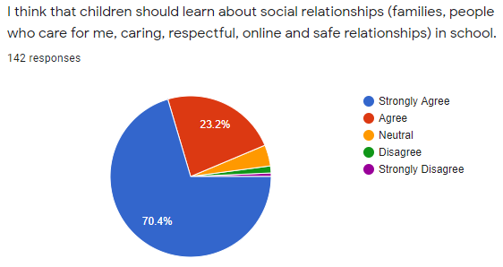
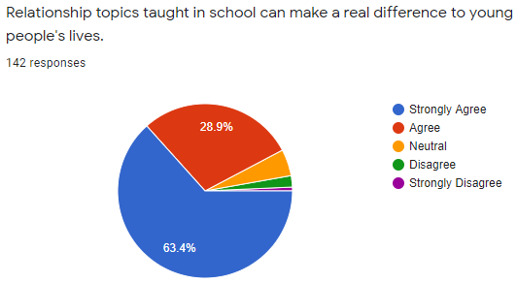
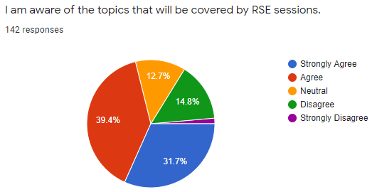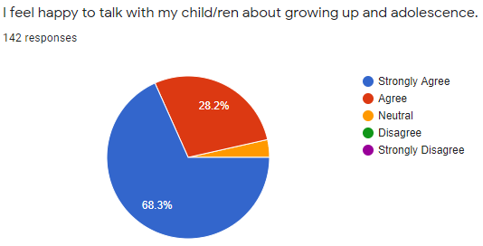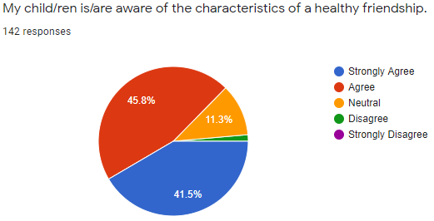
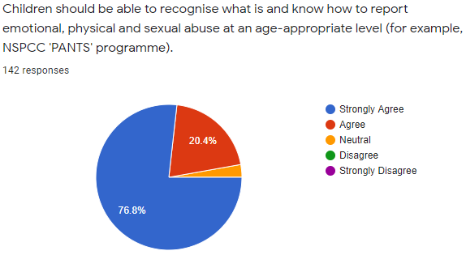
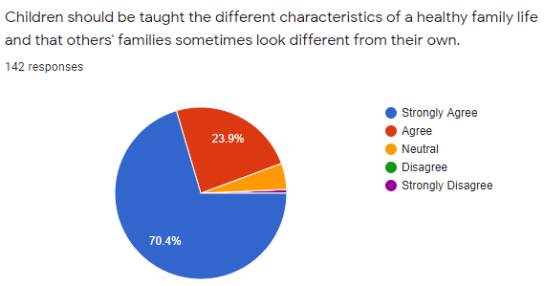

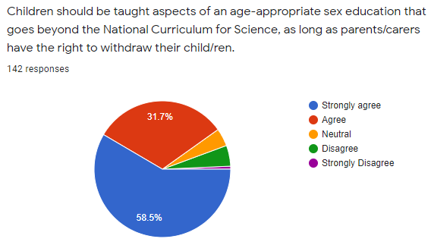

See Annex A for detailed questionnaire feedback.

