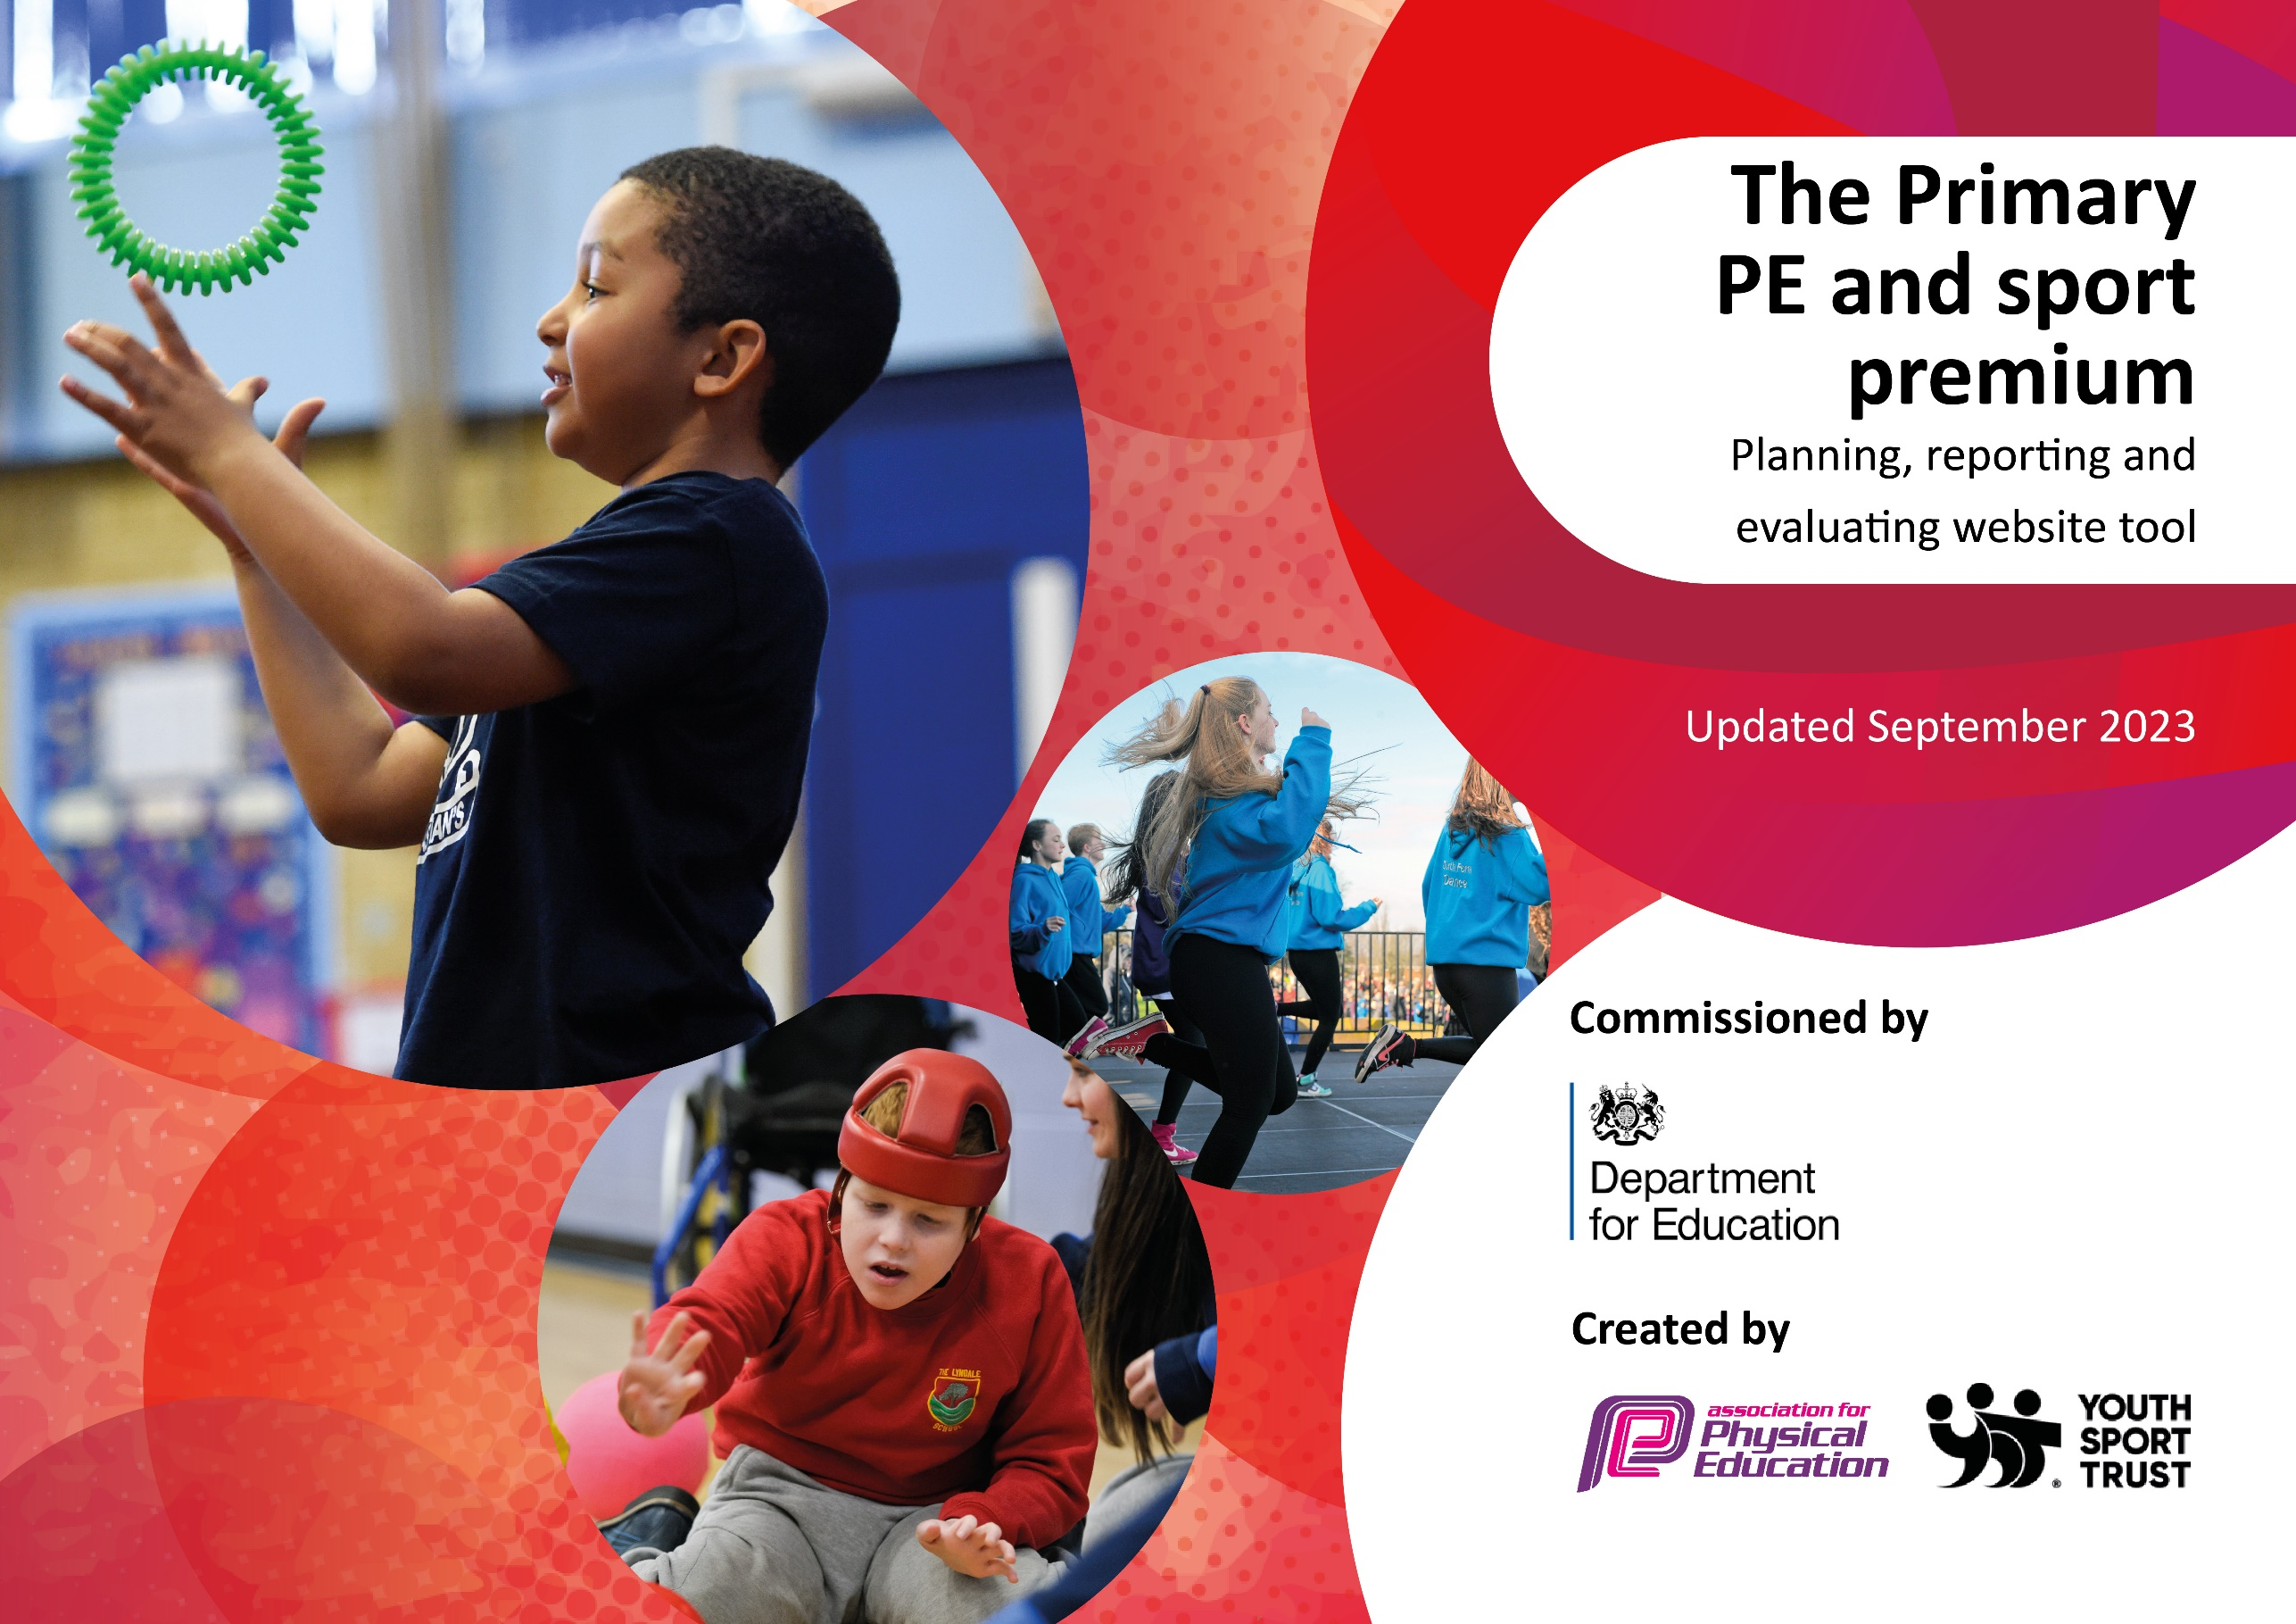

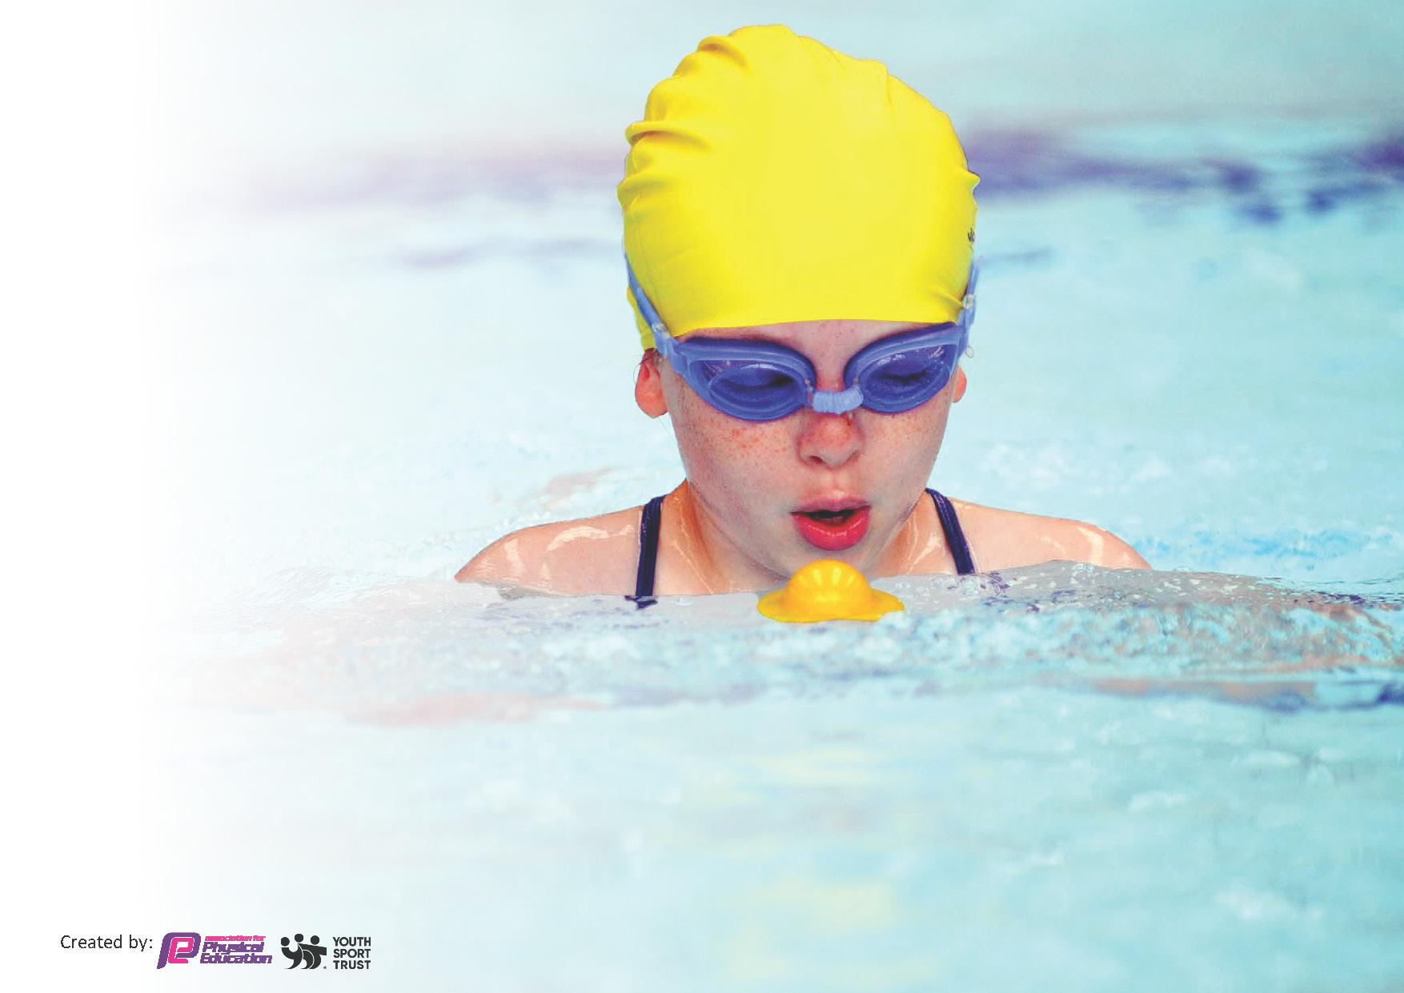
This template can be used for multiple purposes:
by:
- It enables schools to effectively plan their use of the Primary PE and sport premium
- It helps schools to meet the requirements (as set out in guidance) to publish information on their Primary PE and sport premium
- It will be an effective document to support Ofsted inspections enabling schools to evidence progress in Physical Education (PE) and evidence swimming attainment, which forms part of the PE National Curriculum. We would recommend schools consider
the Intent, Implementation and Impact of any spend, as examined within the Education Inspection Framework.

It is important that your grant is used effectively and based on school need.

Schools must use the funding to make additional and sustainable
improvements to the quality of the PE, School Sport and Physical Activity (PESSPA)
they offer. This means that you should use the Primary PE and sport premium to:

- Build capacity and capability within the school to ensure that improvements made now will benefit pupils joining the school in future years
- Develop or add to the PESSPA activities that your school already offers.

The Primary PE and sport premium should not be used to fund capital spend projects; the school’s core budget should fund these. Further detail on capital expenditure can be found in the updated Primary PE and sport premium guidance.

The Primary PE and sport premium guidance, outlines 5 key priorities that funding should be used towards. It is not

necessary that spending has to meet all the key priorities, you should select the priorities that you aim to use any funding towards.

Although completing this template is not a requirement for schools, schools are required to publish details of how they spend this funding. Schools must also outline what the impact this funding has had on pupils’ PE and sport participation and attainment and how any spending will be sustainable in the future. All funding must be spent by 31st July 2024.

The Department for Education has worked closely with the Association for Physical Education (afPE) and the Youth Sport Trust (YST) to develop this template and encourages schools to use it. This template is an effective way of meeting the reporting requirements of the Primary PE and sport premium.
Review of last year’s spend and key achievements (2022/2023)

We recommend you start by reflecting on the impact of current provision and reviewing your previous spend.

Activity/Action | Impact | Comments
- CPD and Training for PE Lead/Coach that was PE specific and more generic to impact more widely across school.  - Development and upskilling of the wider workforce. Mainly working closely with the lunchtime team. Introducing ways to deliver physical activity and utilizing space at lunchtimes.  - Widening the offer of more specialized sports, by spending on new equipment and replenishing existing. | - Improved confidence and knowledge within role. Better understanding on planning, assessment and action planning to link to school improvement planning. Implementing new initiatives around school regarding PE (NIJ Mile/Lunchtime Sports).  - This has made a positive step forward with staff and pupil engagement at lunchtimes. This has allowed them to build better rapport and improve overall behavior during this time of the day. That obviously then improves how pupils return to class in the afternoon. We now also have 2 year groups that take part in organized sport instead of previously 1.  - Pupils now have access to a wider and more specialized sports due to more spending on equipment. This is then coupled with the PE coach, having expertise in other areas of specialized coaching and sports. Together this has increased skill layering on the curriculum. | - This has been a useful area, and something that will continue. This helps understanding the over-arching goals of PE in a school setting.  - It has been great to see a more engaged playground, happier pupils and empowered staff. This will be continued and consistently built upon.  - The pupils have really enjoyed having a more varied curriculum and wrap around offering. It has slightly quicker pace and keeps lessons fresh and exciting. This, then hit the key skill elements of the curriculum.

Key priorities and Planning
This planning template will allow schools to accurately plan their spending.

Action – what are you planning to do | Who does this action impact? | Key indicator to meet | Impacts and how sustainability will be achieved? | Cost linked to the action
- PE Lead/Coach attends regular training sessions to develop their skills in different subjects.  - Extra P.E lessons for pupils every half term so that the P.E lead/coach can teach new skills to other members of staff to build on their confidence.  - Upskill wider areas of the workforce to future proof and foster learning.  - Children will take part in physical activities across all areas of the curriculum where appropriate. This will help the children to reach their 30 minutes of exercise.  - All children to receive 2 hours of P.E per week plus extra P.E lessons every few weeks.  - Children are offered up to 10 sporting clubs per week across mornings and afternoons. Some of these are specialsed and are competition based.  - We have a specific PE and qualified sports coach who ensures that high quality teaching of P.E is seen across the school. They will take pupils to events outside of school to compete as well as experienced teachers who have a link.  - Children’s achievements are recognised in whole school assembly and on the school twitter page. They can also bring in any awards that they have achieved out of school to share with the class.  - P.E has a positive impact within our school, as some children relate strongly to it, which can assist during classroom requirements. We use P.E activities within our lessons where possible.  - We ensure that there are a variety of sports/activities that will suit all children. We like to offer children activities that they may not be able to access at home. | - PE Lead/Coach to complete ‘Team Teach’ course. This supports how to positively manage behavior. All children will have a safer and more supportive environment to engage.  - PE Lead/Coach to attend ‘Primary PE Conference’ to share best practices, work within region and attend a variety of workshops. Positive impact onto children to keep developing school practices.  - PE Lead/Coach to attend ‘Teach Active’ workshop. This shows how to use PE across the curriculum teaching Math’s and English benefitting the engagement of those subjects with more children.  - Designated staff training days allocated for PE development, will broaden confidence and knowledge. This will allow more physical activity throughout the year during and outside of curriculum time.  - Lunchtime staff trained and upskilled to deliver activities and new games during lunchtimes, which will empower them and give children a better experience.  - Offer a Sport/PE session for staff to attend bi-monthly to upskill knowledge of a variety of Sports. This aids in growing confidence in delivering PE across the workforce and will raise profile of physical activity and well-being in school.  - Online and digital platforms such as Seesaw to support the children’s access to learning, development and their experience.  - Using ‘Teach Active’ platform to upskill and grow confidence at teaching English and Math’s using PE.  - Use Training days, to plan some PE specific sessions for staff, to upskill and build on previous knowledge.  - The lunchtime Supervisor and their lunchtime team will organise and deliver games and activities. This will be done in the BBA and rotated daily through each class. Also other activities will be delivered on the playground and surrounding areas too. All of these will be related where possible to curriculum and needs.  - Utilise timetabling opportunities to create opportunity for extra PE lessons delivered by upskilled available staff.  - Run morning and after school sports clubs changing activities/sports each half term to ensure a wide variety of activities for children, and that can support the curriculum.  - New equipment for children to play with at break and lunchtimes. This will include individual items as well as group activities.  - This equipment has also meant that we can offer a wider variety of clubs for the children.  - Using qualified swimming instructors to teach groups in the swimming lessons to give the most effective contact time to pupils.  - Children are fully engaged in their P.E lessons and are learning new skills that they may not experience out of school. Experienced P.E coach will teach technique according to the ability of the children.  - Use the School Games formats for children to become involved in an appropriate level of competition for each year group. This will give them exposure to team work, pressure and understand winning and losing.  - Pupils take part in intra school competitions with the PE coach.  - Being involved in competitions with other schools in the local area.  - Children are learning sports within school that they may not be able to access at home. Also, using sport as a vessel to develop life and soft skills.  - Our school continues to offer a range of sports for the children to participate in including: invasion games, ball and net, gymnastics and dance and multi-sports. We offer these in our P.E lessons, morning clubs, lunchtime clubs and after school clubs.  - We try to range which children are involved in the clubs to give everyone a fair chance of taking part. | Key Indicator 1 and 4  Key Indicator 1, 2 and 4  Key Indicator 1,2,3 and 4  Key Indicator 2 and 3  Key Indicator 1,2,3 and 4  Key Indicator 2,3 and 4  Key Indicator 2  Key Indicator 1,2 and 4  Key Indicator 1,2,3 and 4  Key Indicator 1,2,3,4 and 5  Key Indicator 1,2 and 3  Key Indicator 1 and 4  Key Indicator 1 and 4  Key Indicator 1, 3 and 4  Key Indicator 1 and 4  Key Indicator 4 and 5  Key Indicator 5  Key Indicator 1, 2 and 4  Key Indicator 1, 2 and 4 | Continue to develop the specific staff and wider workforce. This strengthens and creates consistency within roles. This will able to be sustained by having more of the workforce confident to deliver physical activity, allowing relief for PE Lead/Coach to undertake CPD.  Broaden knowledge and raise profile of PE across school. This upskilling will empower and build confidence for more of the workforce to delivery physical activity. This can be sustained as it changes the culture in school to put physical activity more at the forefront day to day.  Stronger knowledge for lunchtime staff will have a positive effect on behavior, as we find that lunchtimes are a challenge. So better quality sport offering will increase engagement of both pupils and staff, resulting in more harmonious lunchtimes.  Using a variety of platforms and tools, gives us a broader spectrum to accessibility and engagement. This allows us to cater for different learning styles. This approach includes how the pupils learn but also a bridge to parents of children.  As the profile of Physical activity and PE grows, time will be allotted to layer up on previous learnt knowledge, thus futureproofing the offering and expertise to pass on to pupils.  Impact will be a more holistic approach to sport and physical activity within the school week. This will help with behavior and rewarding.  A wider range of activities and sports give children more opportunity to build on soft skills (Communication/ Teamwork) needed as they progress through school and life.  Using Swim specific instructors are paramount in giving pupils the best quality contact time for this life-skill.  Sustained high quality, good teaching practice will always be the basic expectation, however when children are exposed to new things, such as sports or events it can spark an interest beyond the learning itself. | £120.00  £75.00  £335.00  £8400.00  £9320.00  £1370.00

Key achievements 2023-2024
This template will be completed at the end of the academic year and will showcase the key achievements schools have made with their Primary PE and sport premium spending.

Activity/Action | Impact | Comments
- Workforce Development- Developing and upskilling of the wider workforce, improving their confidence, knowledge and delivery techniques. Mainly, this has been working closely with the lunchtime team. We have introduced new ways to use outdoor spaces on the playground to create different areas for choices, improved the offer of sport and activity and made sure lunchtimes are more engaging. | - This has made a positive step forward with staff and pupil engagement at lunchtimes. This has allowed the lunchtime team to build better rapport and relationships with the pupils. These relationships then improve overall behavior during this time of the day, as previously, expected levels of behavior can dip.  That obviously then improves how pupils return to class in the afternoon, making learning much stronger.  We now have 2 year groups that take part in organized sport instead of previously 1. This has had a positive effect on the safety of the rest of the playground. | - The staff are far more engaged and happier coming into school, as they feel more part of the working day. We have found in previous years there has been a feeling of detachment.  Children, are responding far better to this new approach to lunchtimes and the playground looks and exciting place to be at lunchtimes.

Swimming Data
Meeting National Curriculum requirements for swimming and water safety.
Priority should always be given to ensuring that pupils can perform safe self-rescue even if they do not fully meet the first two requirements of the National Curriculum programme of study

Question | Stats: | Further context  Relative to local challenges
What percentage of your current Year 6 cohort can swim competently, confidently and proficiently over a distance of at least 25 metres? | 70% | We have no access to a pool for 2 academic years due to refurbishment. Despite this, year 6 percentage is strong.
What percentage of your current Year 6 cohort can use a range of strokes effectively [for example, front crawl, backstroke, and breaststroke]? | 60% | The majority of the 70% can swim more competently than the standard 25m. They have then been exposed to more technical aspects such as strokes at swim schools and clubs.

What percentage of your current Year 6 cohort are able to perform safe self-rescue in different water-based situations? | 40%
If your schools swimming data is below national expectation, you can choose to use the Primary PE and sport premium to provide additional top-up sessions for those pupils that did not meet National Curriculum  requirements after the completion of core lessons. Have you done this? | No | We have been without the opportunity to offer swimming for 2 years, due to our local facility having refurbishment. Other logistical barriers have not allowed us to utilize other facilities and providers.
Have you provided CPD to improve the knowledge and confidence of staff to be able to teach swimming and water safety? | N/A | N/A- We use a Swim school to teach our swim offering. This also benefits our pupils, as the provider can become an exit route to a club.

Signed off by:

Head Teacher: | Alan Pearson
Subject Leader or the individual responsible for the Primary PE and sport premium: | Alex Martin
Governor:
Date:

