New Invention Junior School
Mental to Written Policy


MULTIPLICATION
X

Practical – pictorial – abstract
In order for pupils to develop a concrete understanding of calculation, they should progress through the three stages of formal calculations (practical, pictorial, abstract).

Practical
Addition & subtraction
Pupils should initially be using the following apparatus / equipment to support their understanding of what addition & subtraction means (once place value has been established).

Base ten / Deins
These should be used along with place value mats, initially.

Without bridging 10
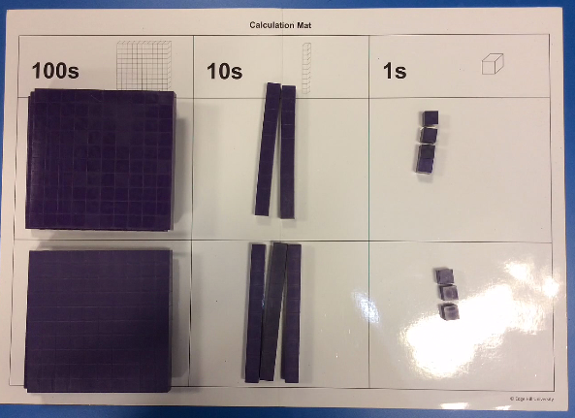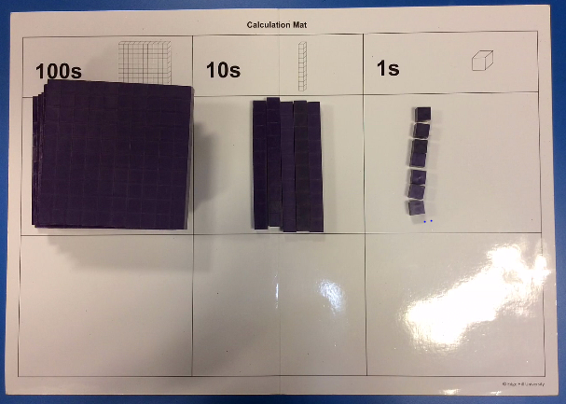
324 + 233 = 557

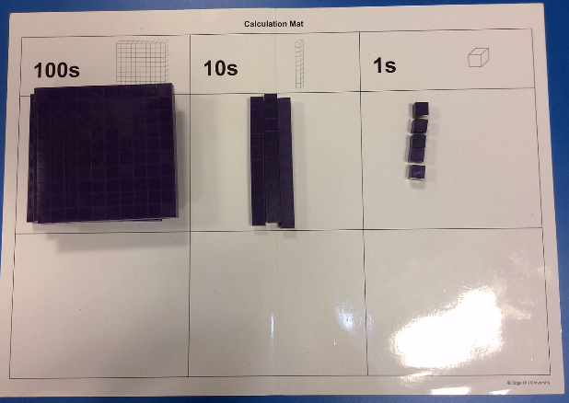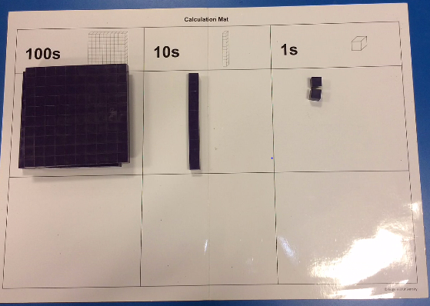
335 – 123 = 212
Bridging 10 / 100
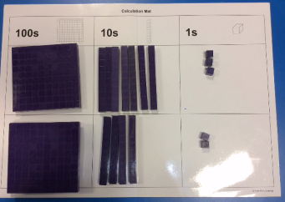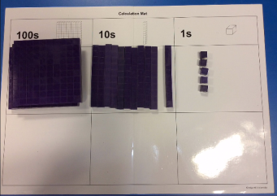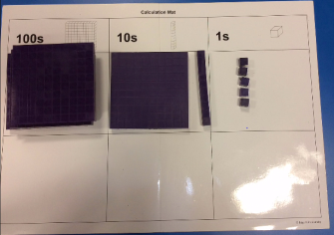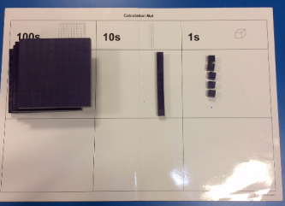
273 + 242 = 515
Pupils should combine and then exchange the tens rods for hundreds blocks, when bridging 10/100’s.
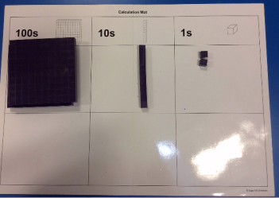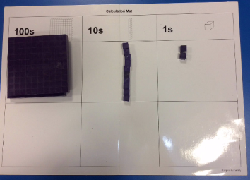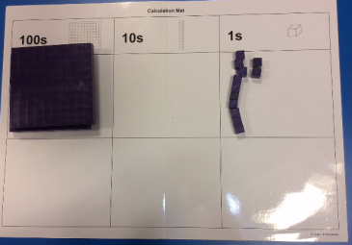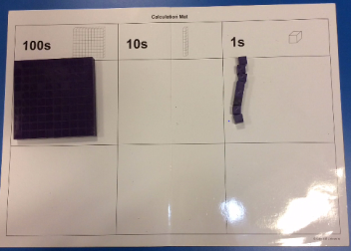
212 – 104 = 108
When subtracting with the need to exchange, pupils should exchange the 100 / 10s rods first before subtracting the required amount.

Numicon
Numicon is ideal for number bonds, especially to 1, 10 and 100. And bonds within 10, 20 and 100. Each shape could represent the whole number corresponding to the holes, or it could represent 10 0r 100 times larger or smaller.
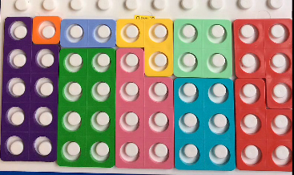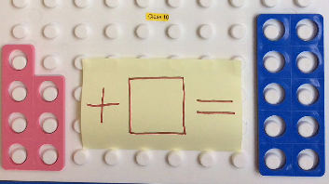
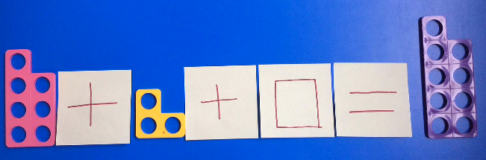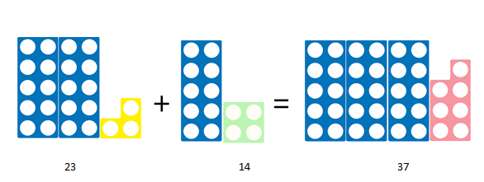

Number rods
Number rods (found in Numicon resources) can be used for demonstrating the bar model, where pupils can see how two numbers are combined to make a larger answer; the rods can therefore represent any value.
These images could represent finding pairs of numbers to equal a larger value, or finding the missing value needed to be added to a smaller number or subtracted from a larger number.

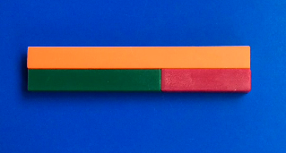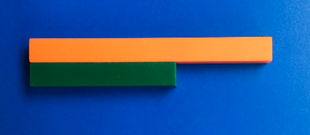
Multiplication & division
Pupils should initially be using the following apparatus / equipment to support their understanding of what multiplication means (once place value has been established).

Base ten / Deins
Numicon
This an ideal resource to represent arrays as a model of multiplication or division.
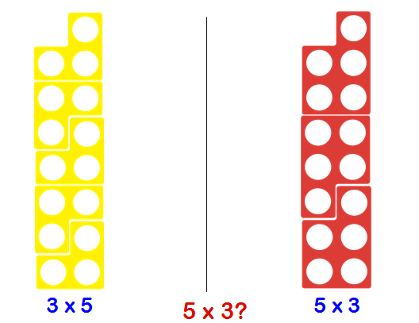
Division can also be shown in both ways, using Numicon: as sharing or grouping.

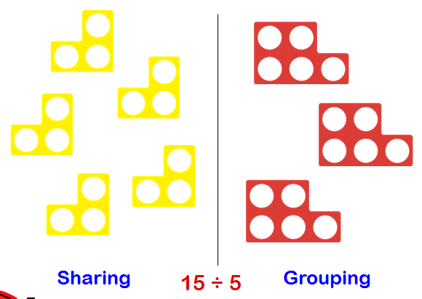

Number rods
Number rods or bar model, can be used for division or scaling, to identify how many of one value fit in to the larger value.
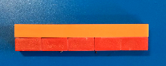

These rods represent 2 x 5 being equal to 10, or 10 split equally in to 5 is 2.

Pictorial
Once pupils are secure with practical apparatus and can explain concepts using it, they should then be moving on to representing calculations pictorially, as shown below.
Addition & subtraction
Bar Model
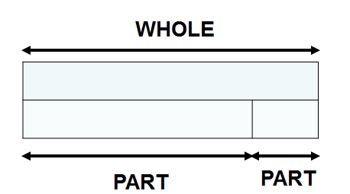

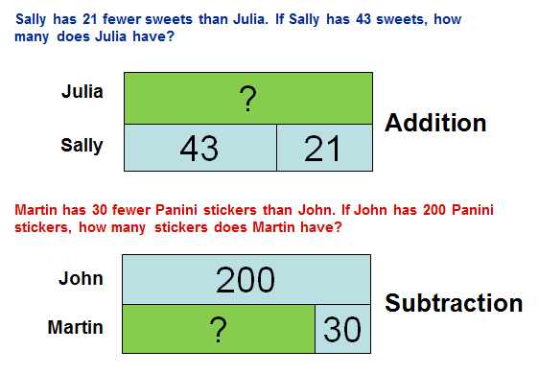

Multiplication & Division
Bar Model
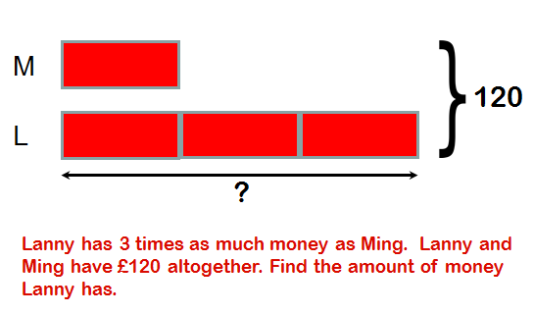
Abstract
Mental Calculations
Most mental calculations can be solved using the strategies of Rapa Coda Numbo. This is an acronym for five different strategies. (please refer to our visual calculation policy – TBA)
RA – Round & Adjust
PA – Partitioning
CO – count on/back
DA – double & adjust
Numbo – Number Bonds

RA
Round and adjust can be used when a number is close to a multiple of 10, 100 or 1000, in order to make it quicker to add, subtract or multiply. The answer will then have to be adjusted to compensate for rounding.
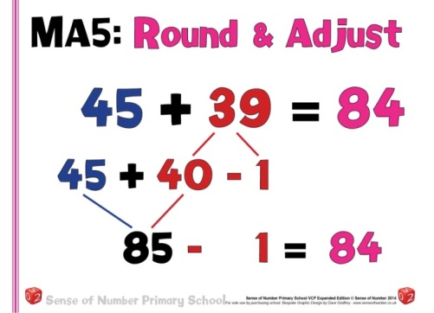

PA
Partitioning a number means to split it in to its place value, and calculate each digit separately before recombining. This can be used for addition, subtraction and multiplication.
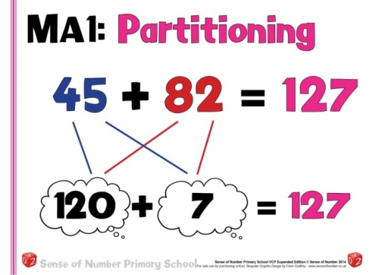

CO
Count on or back can be used for both addition and subtraction. It is simply starting at one of the numbers and counting in 1’s, 2’s 10 etc. till the final number is reached.
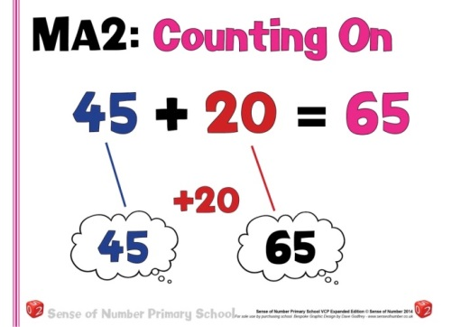

DA
Double and adjust is ideally suited to addition, subtraction and multiplication. When a pair of numbers are close to being equal, the calculation can be carried out as if they were the same and then the answer adjusted accordingly.
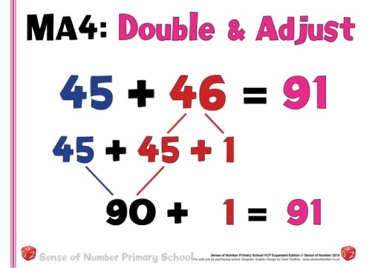

Numbo
Number bonds are essential for quick mental calculation, with known number bonds to and within 10, these can then be used to derive a range of addition and subtraction calculations.
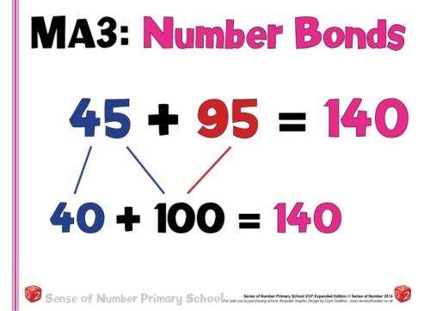

Mental multiplication of Numbers
To multiply successfully, children need to be able to:
Year 3 | Year 4 | Year 5 | Year 6
Know 8x table  Know the 3x and 4x tables  Double numbers up to 50 (without bridging 10)  Double numbers up to 100 (without bridging 10)  Partition 2 digit numbers to 20, to multiply by a single digit number (3 x 14 as 3x10 and 3x4) | Know 2, 5 & 10 times tables & corresponding division facts  Know 3, 4 & 8 times tables & corresponding division facts  Know 6, 7 & 9 times tables  Begin to double and halve amounts of money, not bridging whole pounds (£35.20 doubles = £70.40)  Begin to double and halve amounts of money, bridging whole pounds (£35.60 doubles = £71.20)  Partition 2-digit numbers to multiply by a single –digit number mentally (4 x 24 as 4 x 20 and 4 x 4) (Rapa Coda Numbo)  Use understanding of place value and number facts in mental multiplication and division (36 x 5 is half of 36 x 10 and 50 x 60 = 3000 or 245 ÷20 is double 245 ÷ 10)  Multiply multiples of 10 by 1-digit numbers, using known times tables (40 x 8 = 320) | Know 2, 5 & 10 times tables & corresponding divisions  Know 3, 4 & 8 times tables & corresponding divisions  Know 6, 7 & 9 times tables & corresponding divisions  Know 11 & 12 times tables  Double and halve money by partitioning (Half of £75.40 = Half of £75 (37.50) plus half of 40p)  Use doubling and halving as mental division/multi strategies (58 x 5 = half of 58 x 10, 43 x 6 is double 43 x 3 and 28 x 50 is half of 28 x 100 = 1400) | Know by heart all multiplication facts up to 12 x 12  Identify common factors to solve mental multiplication (326 x 6 is 652 x 3 )  Use rounding in mental multiplication (34 x 19 as 20 x34) (Rapa Coda Numbo)  Double decimal numbers with up to 2 places using partitioning (36.73 doubled is double 36 plus double 0 .73)  Use doubling and halving as a mental division and multiplication strategy. (to divide by 2,4,8,5,20 and 25 (628 ÷ 8 is halved three times) (28 x 25 is ¼ of 28 x 100 = 700)  Know square numbers to 144

Written multiplication of Numbers

Stage 1: Numberline and arrays
- By Year 3  - Children should model multiplication using arrays, which will later on, mirror the grid method  - Children will continue to use repeated addition, for example: 6 x 4 is 6+6+6+6=24  - Children should use number lines or bead bars to support their understanding. | 9 x 4 = 36  +6 +6 +6 +6  0 6 12 18 24
Stage 2: Informal methods
- By Year 3  - Multiplication using partitioning: Mental methods for multiplying TU × U can be based on the distributive law of multiplication over addition. This allows the tens and units to be multiplied separately to form partial products. These are then added to find the total product. Either the tens or the units can be multiplied first but it is more common to start with the tens.  - These methods are based on the distributive law. Children should be introduced to this (not by name) in years 2 & 3, when they can apply their knowledge of 2, 5 and 10 rimes tables to work out multiples of 4 etc. | 43 x 6  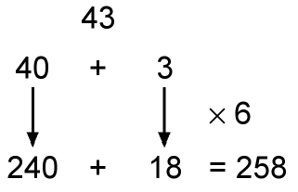  Also record mental multiplication using partitioning:  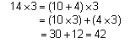  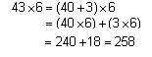
Stage 3: The grid method
- By Year 3/4  - As a staging post, an expanded method which uses a grid can be used. This is based on the distributive law and links directly to the mental method. It is an alternative way of recording the same steps.  - It is better to place the number with the most digits in the left-hand column of the grid so that it is easier to add the partial products.  - Extend to TU × TU, asking children to estimate first.  - When the teacher is confident that written estimates are accurate they may be omitted.  - Start with the grid method. The partial products in each row are added, and then the two sums at the end of each row are added to find the total product. | 38 × 7 = 266  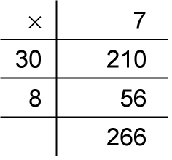  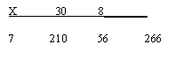  NB This method is not formally tested, but is an important stepping stone.  56 × 27 is approximately  60 × 30 = 1800.  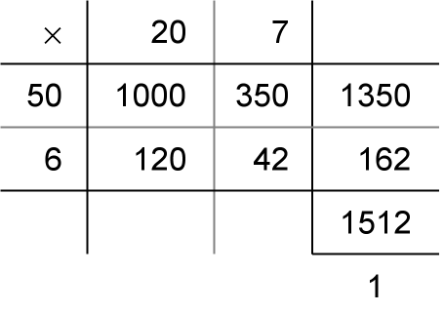
Stage 4: Expanded short multiplication
- By Year 5  - The next step is to represent the method of recording in a column format, but showing the working. Draw attention to the links with the grid method above.  - Children should describe what they do by referring to the actual values of the digits in the columns. For example, the first step in 38 × 7 is ‘thirty multiplied by seven’, not ‘three times seven’, although the relationship 3 × 7 should be stressed.  - Most children should be able to use this expanded method for TU × U by the end of Year 4.  - For TU x TU follow the same steps as above, recording a new line at each stage. | 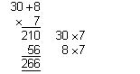  56 × 27 is approximately 60 × 30 = 1800.  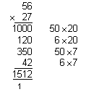
Stage 5: Short multiplication
- By Year 5/6  - The recording is reduced further, with carry digits recorded below the line.  - If, after practice, children cannot use the compact method without making errors, they should return to the previous method.  - For TU x TU continue in this way, however an extra step is needed in the recording, due to an extra tens column needing to be multiplied. | 56 × 27 is approximately 60 × 30 = 1800.

