New Invention Junior School
Mental to Written Policy


DIVISION
÷
Practical – pictorial – abstract
In order for pupils to develop a concrete understanding of calculation, they should progress through the three stages of formal calculations (practical, pictorial, abstract).

Practical
Addition & subtraction
Pupils should initially be using the following apparatus / equipment to support their understanding of what addition & subtraction means (once place value has been established).

Base ten / Deins
These should be used along with place value mats, initially.

Without bridging 10
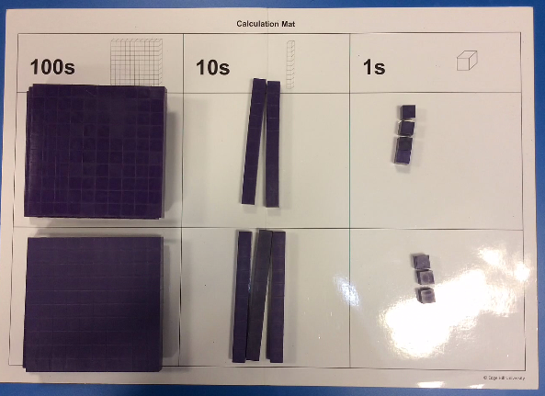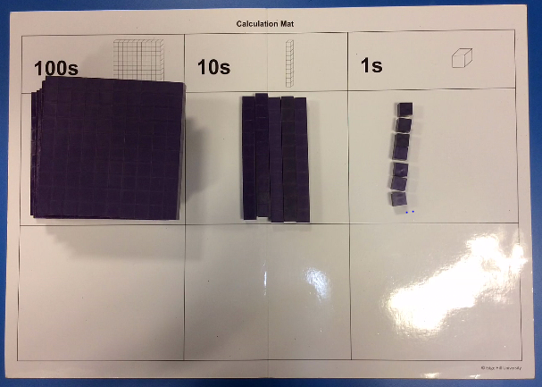
324 + 233 = 557

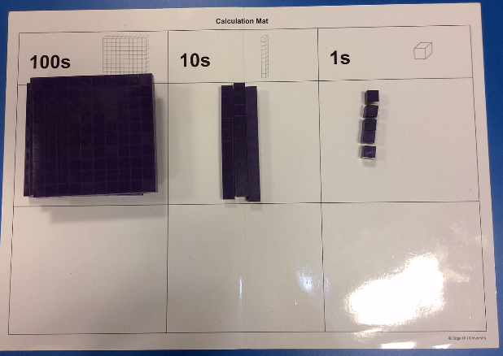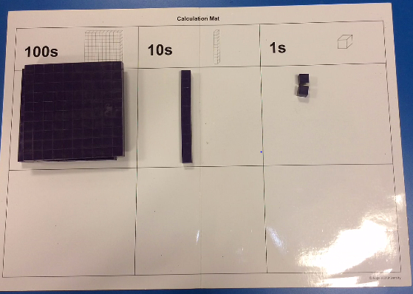
335 – 123 = 212
Bridging 10 / 100
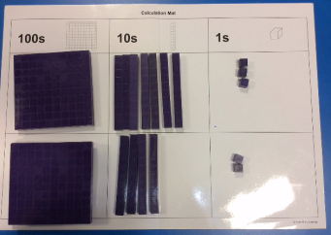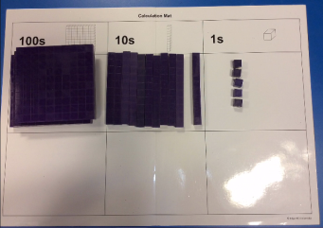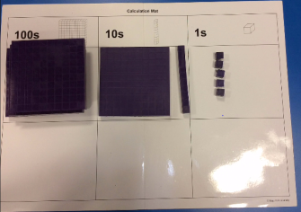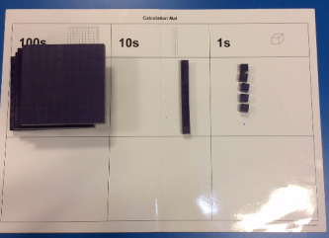
273 + 242 = 515
Pupils should combine and then exchange the tens rods for hundreds blocks, when bridging 10/100’s.
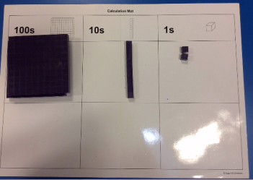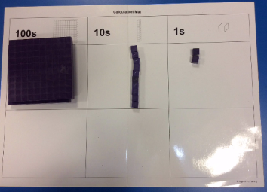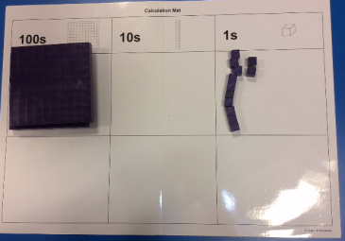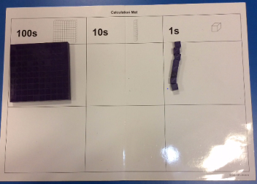
212 – 104 = 108
When subtracting with the need to exchange, pupils should exchange the 100 / 10s rods first before subtracting the required amount.

Numicon
Numicon is ideal for number bonds, especially to 1, 10 and 100. And bonds within 10, 20 and 100. Each shape could represent the whole number corresponding to the holes, or it could represent 10 0r 100 times larger or smaller.
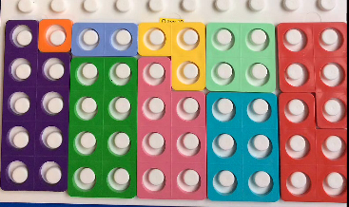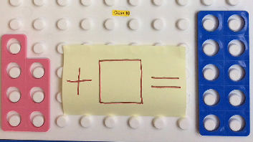
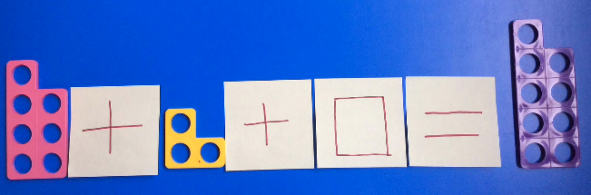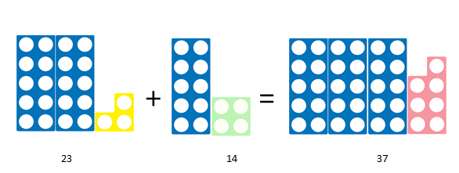

Number rods
Number rods (found in Numicon resources) can be used for demonstrating the bar model, where pupils can see how two numbers are combined to make a larger answer; the rods can therefore represent any value.
These images could represent finding pairs of numbers to equal a larger value, or finding the missing value needed to be added to a smaller number or subtracted from a larger number.

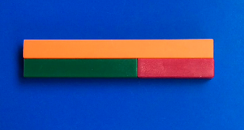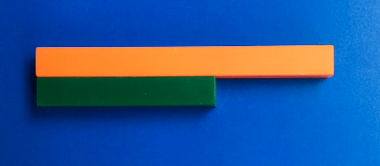
Multiplication & division
Pupils should initially be using the following apparatus / equipment to support their understanding of what multiplication means (once place value has been established).

Base ten / Deins
Numicon
This an ideal resource to represent arrays as a model of multiplication or division.
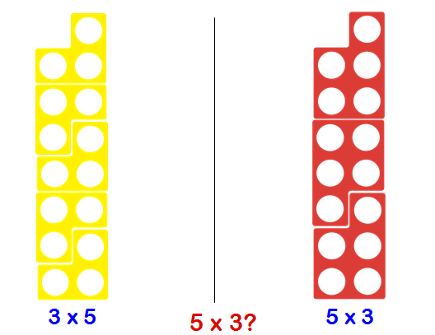
Division can also be shown in both ways, using Numicon: as sharing or grouping.

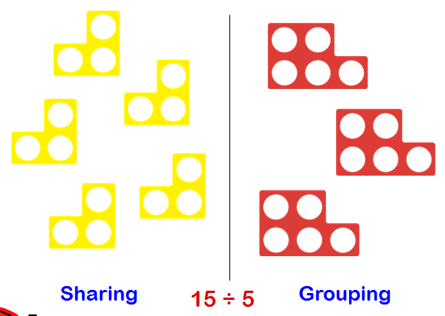

Number rods
Number rods or bar model, can be used for division or scaling, to identify how many of one value fit in to the larger value.
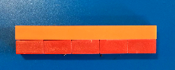

These rods represent 2 x 5 being equal to 10, or 10 split equally in to 5 is 2.

Pictorial
Once pupils are secure with practical apparatus and can explain concepts using it, they should then be moving on to representing calculations pictorially, as shown below.
Addition & subtraction
Bar Model
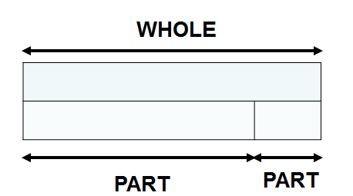

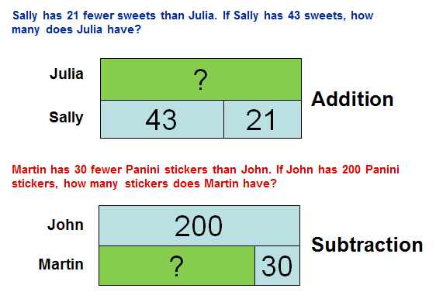

Multiplication & Division
Bar Model
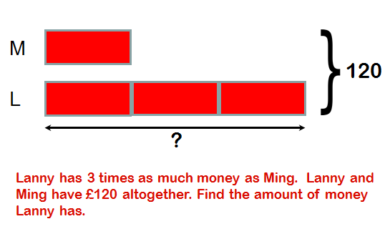
Abstract
Mental Calculations
Most mental calculations can be solved using the strategies of Rapa Coda Numbo. This is an acronym for five different strategies. (please refer to our visual calculation policy – TBA)
RA – Round & Adjust
PA – Partitioning
CO – count on/back
DA – double & adjust
Numbo – Number Bonds

RA
Round and adjust can be used when a number is close to a multiple of 10, 100 or 1000, in order to make it quicker to add, subtract or multiply. The answer will then have to be adjusted to compensate for rounding.
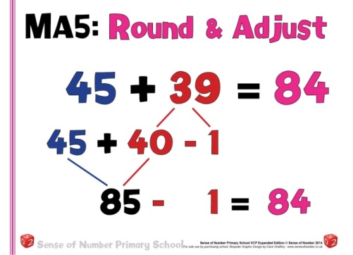

PA
Partitioning a number means to split it in to its place value, and calculate each digit separately before recombining. This can be used for addition, subtraction and multiplication.
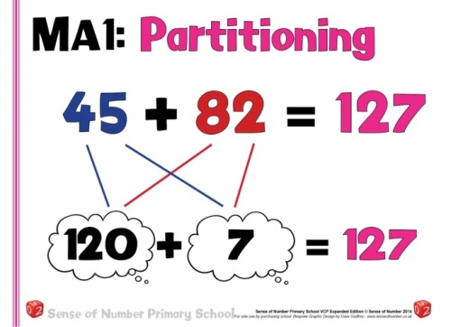

CO
Count on or back can be used for both addition and subtraction. It is simply starting at one of the numbers and counting in 1’s, 2’s 10 etc. till the final number is reached.
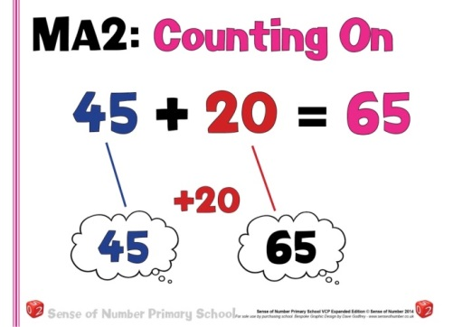

DA
Double and adjust is ideally suited to addition, subtraction and multiplication. When a pair of numbers are close to being equal, the calculation can be carried out as if they were the same and then the answer adjusted accordingly.
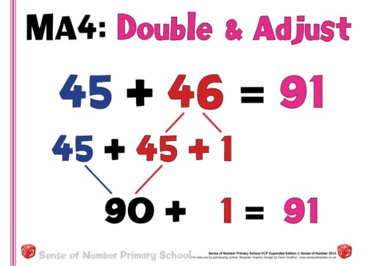

Numbo
Number bonds are essential for quick mental calculation, with known number bonds to and within 10, these can then be used to derive a range of addition and subtraction calculations.
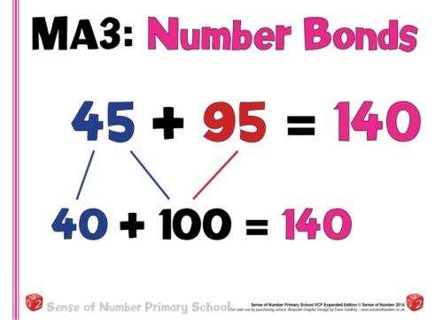

Mental division of Numbers
To divide successfully, children need to be able to:
Year 3 | Year 4 | Year 5 | Year 6
Halve even numbers up to 100  Halve tens numbers to 100  Know related division facts for 8x table | Know 2, 5 & 10 times tables & corresponding division facts  Know 3, 4 & 8 times tables & corresponding division facts  Know corresponding division facts for 6s, 7s and 9s  Begin to double and halve amounts of money, not bridging whole pounds (£35.20 doubles = £70.40)  Begin to double and halve amounts of money, bridging whole pounds (£35.60 doubles = £71.20)  Divide multiples of 10 or 100 by 1-digit numbers using division facts (320 ÷ 8= 40) | Know 2, 5 & 10 times tables & corresponding divisions  Know 3, 4 & 8 times tables & corresponding divisions  Know 6, 7 & 9 times tables & corresponding divisions  Know corresponding division facts for 11 & 12s  Double and halve money by partitioning (Half of £75.40 = Half of £75 (37.50) plus half of 40p)  Use doubling and halving as mental division/multi strategies (58 x 5 = half of 58 x 10, 43 x 6 is double 43 x 3 and 28 x 50 is half of 28 x 100 = 1400)  Know square roots up to 144 | Know by heart all division facts up to 12 x 12  Use place value and number facts to derive division calculations (42,000 ÷ 6 = 7,000 320 ÷ 8 = 40)  Identify common factors to solve mental division (438 ÷ 6 is 219 ÷ 3)  Halve decimal numbers with up to 2 places using partitioning (36.73 doubled is double 36 plus double 0 .73)  Use doubling and halving as a mental division and multiplication strategy. (to divide by 2,4,8,5,20 and 25 (628 ÷ 8 is halved three times) (28 x 25 is ¼ of 28 x 100 = 700)  Know square roots to 144

Written division of Numbers

Stage 1: Numberline division
- By Year 3  - An emphasis in year three should be made on ‘grouping’ rather than ‘sharing’.  - Pupils should use an empty number line to find repeated groups of a number, to reach another number, by counting up.  - Repeated subtraction should then also be done in the same way, to show that we can identify how many groupings are in a number, in either direction on a numberline.  - Children should also be taught these methods which include remainders too.  - The multiples that are added or subtracted can now also be referred to as ‘chunks’, in order to aid progression on to the next stage. | 180 ÷ 6 = 30  10 x 6 10 x 6 10 x 6 = 30 x 6  0 60 120 180  24 ÷ 4 = 6  2x4 2x4 2x4 = 6 x 4  0 8 16 24
Stage 2: Short Division
- By Year 4/5  - Short division of a two-digit number can be introduced to children who are confident with multiplication and division facts and with subtracting multiples of 10 mentally, and whose understanding of partitioning and place value is sound.  - For most children this will be at the end of Year 4 or the beginning of Year 5.  - When explaining we say ‘How many 3 tens are in 80?’ and what is the remainder (if any), modelling how to carry the remaining tens to the next column, then repeat ‘How many 3 ones are in 21?’  - ‘Short’ division of HTU ÷ U can be introduced as an alternative, more compact recording. | For 81 ÷ 3  The short division method is recorded like this:  81 ÷ 3 =  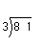  . .27…  3) 8²1  The short division method is recorded like this:  The carry digit ‘2’ represents the 2 tens that have been exchanged for 20 units. In the first recording above it is written in front of the 1 to show that a total of 21 units are to be divided by 3.
Stage 3: Chunking method
- By Year 5  - This method is based on subtracting multiples of the divisor from the number to be divided, the dividend.  - For TU ÷ U there is a link to the mental method.  - As you record the division, ask: ‘How many nines in 90?’ or ‘What is 90 divided by 9?’  - Once they understand and can apply the method, children should be able to move on from TU ÷ U to HTU ÷ U quite quickly as the principles are the same.  - This method, often referred to as ‘chunking’, is based on subtracting multiples of the divisor, or ‘chunks’. Initially children subtract several chunks, but with practice they should look for the biggest multiples of the divisor that they can find to subtract.  - Chunking is useful for reminding children of the link between division and repeated subtraction.  - However, children need to recognise that chunking is inefficient if too many subtractions have to be carried out. Encourage them to reduce the number of steps and move them on quickly to finding the largest possible multiples.  - Children who have a secure knowledge of multiplication facts and place value should be able to move on quickly to the more efficient recording on the right.  - By Year 5  - Children should then progress to HTU divided by TU, which is recorded in the same way | 97 ÷ 9  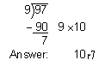  To find 196 ÷ 6, we start by multiplying 6 by 10, 20, 30, … to find that 6 × 30 = 180 and 6 × 40 = 240. The multiples of 180 and 240 trap the number 196. This tells us that the answer to 196 ÷ 6 is between 30 and 40.  Start the division by first subtracting 180, leaving 16, and then subtracting the largest possible multiple of 6, which is 12, leaving 4.  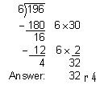  The quotient 32 (with a remainder of 4) lies between 30 and 40, as predicted.  How many packs of 24 can we make from 560 biscuits? Start by multiplying 24 by multiples of 10 to get an estimate. As 24 × 20 = 480 and 24 × 30 = 720, we know the answer lies between 20 and 30 packs. We start by subtracting 480 from 560.  