New Invention Junior School

Mental to Written Policy



ADDITION

+

**Practical – pictorial – abstract**

In order for pupils to develop a concrete understanding of calculation, they should progress through the three stages of formal calculations (practical, pictorial, abstract).

**Practical**

**Addition & subtraction**

Pupils should initially be using the following apparatus / equipment to support their understanding of what addition & subtraction means (once place value has been established).

**Base ten / Deins**

These should be used along with place value mats, initially.

*Without bridging 10*

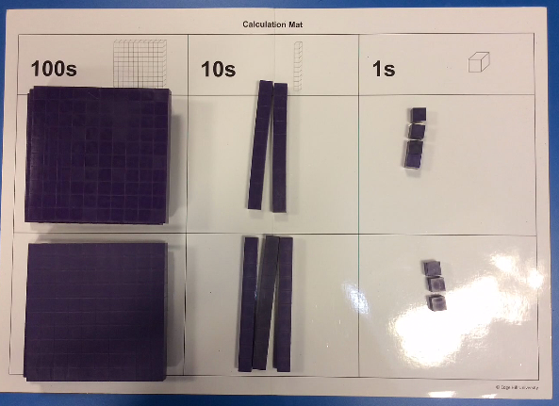 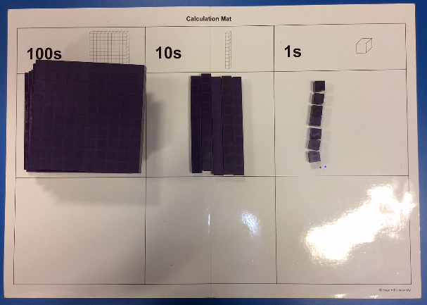

**324 + 233 = 557**

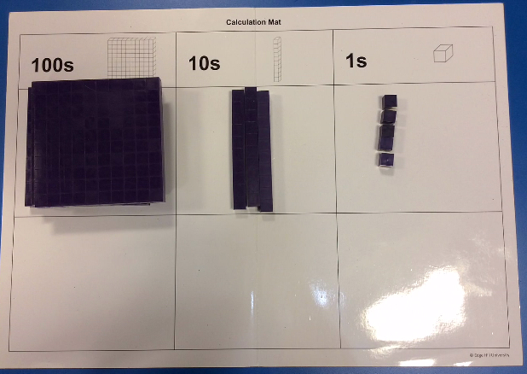 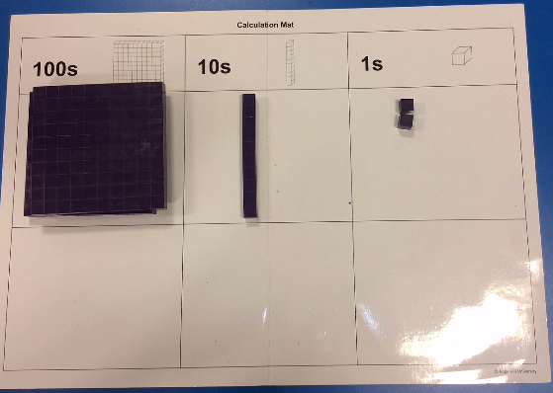

**335 – 123 = 212**

*Bridging 10 / 100*

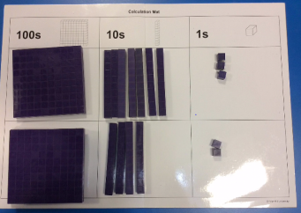 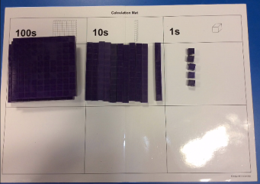 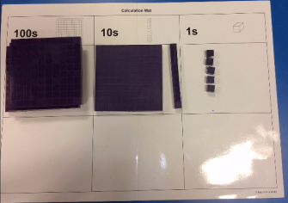 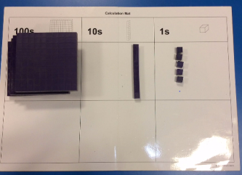

**273 + 242 = 515**

Pupils should combine and then **exchange** the tens rods for hundreds blocks, when bridging 10/100’s.

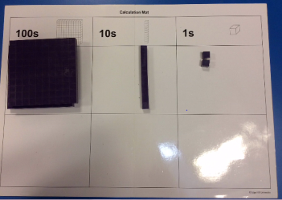 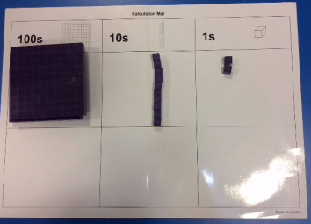 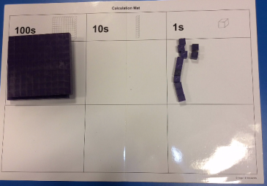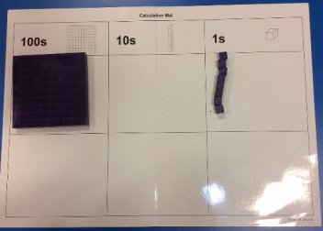

**212 – 104 = 108**

When subtracting with the need to **exchange**, pupils should exchange the 100 / 10s rods first before subtracting the required amount.

**Numicon**

Numicon is ideal for number bonds, especially to 1, 10 and 100. And bonds within 10, 20 and 100. Each shape could represent the whole number corresponding to the holes, or it could represent 10 0r 100 times larger or smaller.

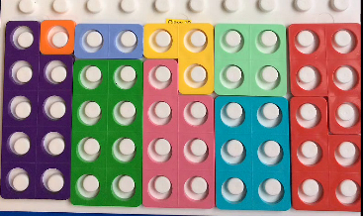 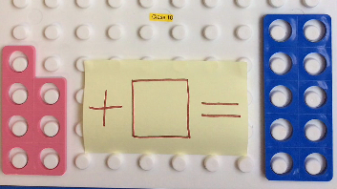

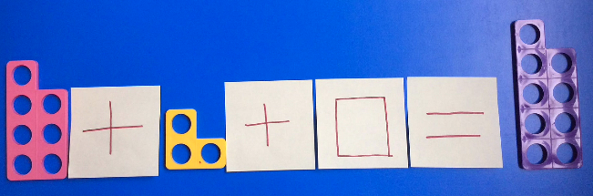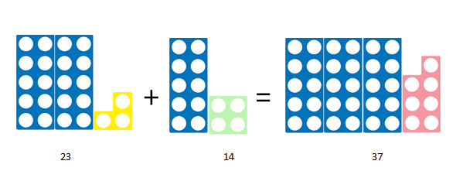

**Number rods**

Number rods (found in Numicon resources) can be used for demonstrating the bar model, where pupils can see how two numbers are combined to make a larger answer; the rods can therefore represent any value.

These images could represent finding pairs of numbers to equal a larger value, or finding the missing value needed to be added to a smaller number or subtracted from a larger number.

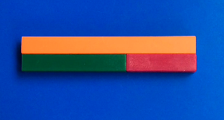 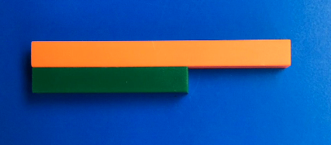

**Multiplication & division**

Pupils should initially be using the following apparatus / equipment to support their understanding of what multiplication means (once place value has been established).

**Base ten / Deins**

**Numicon**

This an ideal resource to represent arrays as a model of multiplication or division.

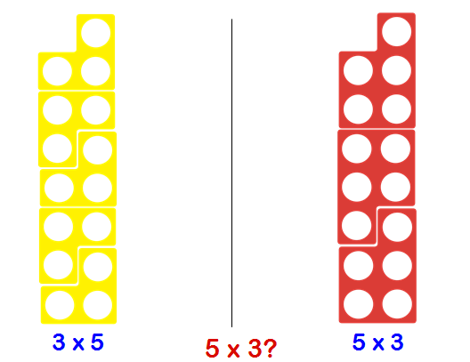

Division can also be shown in both ways, using Numicon: as sharing or grouping.

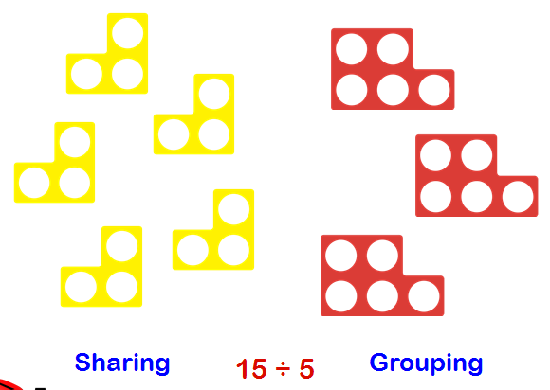

**Number rods**

Number rods or bar model, can be used for division or scaling, to identify how many of one value fit in to the larger value.

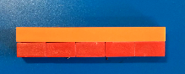

These rods represent 2 x 5 being equal to 10, or 10 split equally in to 5 is 2.

**Pictorial**

Once pupils are secure with practical apparatus and can explain concepts using it, they should then be moving on to representing calculations pictorially, as shown below.

**Addition & subtraction**

**Bar Model**

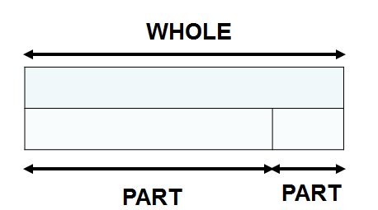

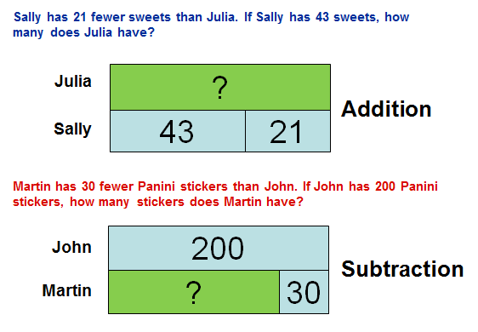

**Multiplication & Division**

**Bar Model**

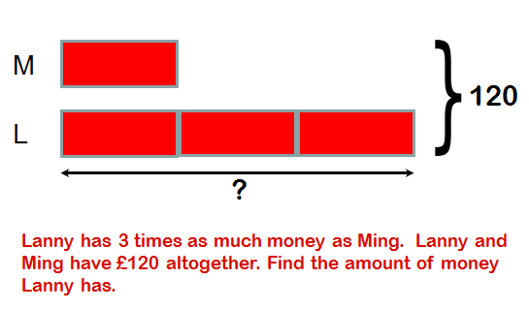

**Abstract**

**Mental Calculations**

Most mental calculations can be solved using the strategies of Rapa Coda Numbo. This is an acronym for five different strategies. *(please refer to our visual calculation policy – TBA)*

**RA** – Round & Adjust

**PA** – Partitioning

**CO** – count on/back

**DA** – double & adjust

**Numbo** – Number Bonds



**RA**

Round and adjust can be used when a number is close to a multiple of 10, 100 or 1000, in order to make it quicker to add, subtract or multiply. The answer will then have to be adjusted to compensate for rounding.

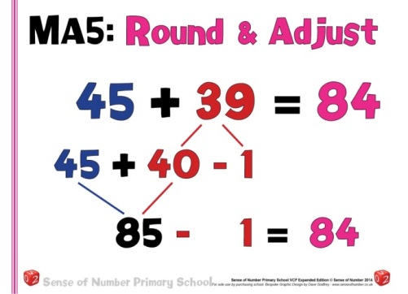

**PA**

Partitioning a number means to split it in to its place value, and calculate each digit separately before recombining. This can be used for addition, subtraction and multiplication.

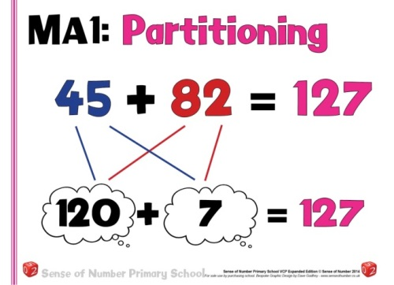

**CO**

Count on or back can be used for both addition and subtraction. It is simply starting at one of the numbers and counting in 1’s, 2’s 10 etc. till the final number is reached.

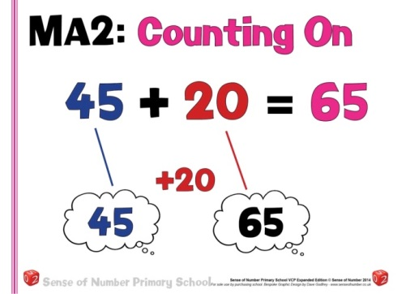

**DA**

Double and adjust is ideally suited to addition, subtraction and multiplication. When a pair of numbers are close to being equal, the calculation can be carried out as if they were the same and then the answer adjusted accordingly.

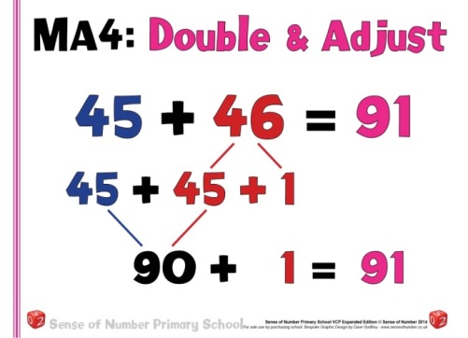

**Numbo**

Number bonds are essential for quick mental calculation, with known number bonds to and within 10, these can then be used to derive a range of addition and subtraction calculations.

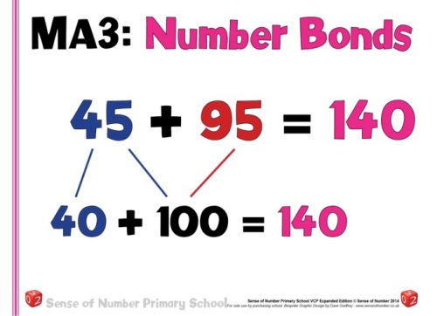

**Mental addition of numbers**

To add successfully, children need to be able to:

|  |  |  |  |
| --- | --- | --- | --- |
| **Year 3** | **Year 4** | **Year 5** | **Year 6** |
| Know number bonds to and within 10  Know number binds to and within 20  Add three digit numbers and 1s  Add three digit numbers and 10s  Add three digit numbers and 100s  Add pairs of 2 digit numbers without bridging 10  Find 10 or 100 more/less than a given number  Add 2 digit numbers, to 20, by counting on in 10s and 1s  Add any 2 digit numbers by counting on in 10s and 1s | Find 1000 more/less than a given number  Find 1100 / 110 more/less than any given number  Add and subtract £1, 10p and 1p to amounts of money *(Rapa Coda Numbo)*  Know by heart, quickly derive number bonds to 100 and £1  Add any two 2 digit numbers by partitioning or counting on *(Rapa Coda Numbo)* | Find 1100 / 110 / 11 more or less than any given number  Know number bonds to 1 and to the next whole number  Identify number bonds to 10, 1 and 100, including money and decimals, to solve addition of 3 or more numbers *(3+4+8+6+7, 0.6+0.4+0.7) (Rapa Coda Numbo)*  Add to the next 10 from a decimal number *(13.6 + 6.4 =20).*  Add and subtract decimal numbers which are near multiples of 1 or 10, including money *(£6.34-1.99 or £34.59-£19.95) (Rapa Coda Numbo)*  Add two 1-decimal-place numbers, not bridging 10  Add two 1-decimal-place numbers, bridging 1 | Add positive number to negative numbers *( calculate a rise in temp)*  Add two 1-decimal-place numbers less than 1 *(4.5 + 6.5)*  Add two 1-decimal-place numbers or two 2-place decimal numbers less than 1 *(0.74 +0.33)* |

**Written addition of numbers**

|  |  |
| --- | --- |
| **Stage 1: The empty number line** |  |
| * By **Year 2** * The mental methods that lead to column addition generally involve partitioning, e.g. adding the tens and units separately, often starting with the tens. Children need to be able to partition numbers in ways other than into tens and ones to help them make multiples of ten by adding in steps. * The empty number line helps to record the steps on the way to calculating the total. * In the first stages of formal writing, number lines are drawn in pencil in books – using a ruler. The horizontal calculation is recorded above the number line. The answer is left blank than filled in after the numberline calculation is completed. | Steps in addition can be recorded on a number line. The steps often bridge through a multiple of 10.  8 + 7 = 15  Calc1  48 + 36 = 84  Calc2    or:  or Calc3 |
| **Stage 2: Partitioning** |  |
| * By **Year 3** * The next stage is to record mental methods using partitioning. Add the tens and then the units to form partial sums and then add these partial sums. * Partitioning both numbers into tens and units mirrors the column method where units are placed under units and tens under tens. This also links to mental methods. * By the **end of Year 3** pupils should extend this to adding 3 digit numbers. | Partitioned numbers are written under one another:   1. = 30 + 1   +24 20 + 4  50 + 5 = 55    147 = 100 + 40 + 7  176 100 + 70 + 6  200 + 110 + 13 = 323 |
| **Stage 3: Expanded method in columns** |  |
| * By **Year 3** * Move on to a layout showing the addition of the tens to the tens and the units to the units separately. To find the partial sums either the tens or the units can be added first, and the total of the partial sums can be found by adding them in any order. As children gain confidence, ask them to start by adding the units digits first always. * The addition of the tens in the calculation 47 + 76 is described in the words ‘forty plus seventy equals one hundred and ten’, stressing the link to the related fact ‘four plus seven equals eleven’. * The expanded method leads children to the more compact method so that they understand its structure and efficiency. The amount of time that should be spent teaching and practising the expanded method will depend on how secure the children are in their recall of number facts and in their understanding of place value. | Write the numbers in columns.  Adding the units first:    Discuss how adding the units first gives the same answer as adding the tens first. Refine to adding the units digits first consistently.  Note the + sign is always positioned to the left and is always one square to the left of any number.  134  + 12  6  140  146 |
| **Stage 4: Column method** |  |
| * By **Year 4** * In this method, recording is reduced further. Carry digits are recorded below the line, using the words **‘carry ten’** or **‘carry one hundred**’, not ‘carry one’. * Later, extend to adding three two-digit numbers, two three-digit numbers and numbers with different numbers of digits. * By the **end of Year 4** pupils should extend this to adding 4 digit numbers. | Column addition remains efficient when used with larger whole numbers and decimals. Once learned, the method is quick and reliable.  147 2147  + 176 1176  323 3323  1 1 1 1 |